**03Jul24**

**SOP update 03Jul24**

I need to dump moar RAM into the immaterium

3rd times a charm!

Why so much ai implementation after 05may24? Windows 11, amazin rufus, goodle ai search, etc, etc, they are clamoring for more data = more smart ai= better weapon of control

Is some spirit filled rap speaking in tongues and poetry? Like the song truth, way, life? I 100% believe this, God invented rap, his followers speaking in tongues were the OG rappers bruh.

Life is sooo much easier without worshiping fear,

His power is kind of like the infinite spell slot mod for BG 3

Look how far you've fallen, from a morning star I heaven to xxx

This will be you legacy… for all eternity

All we need now is for Epstein's list to be released so that we may hunt and burn the pedophiles publically through the web of the immaterium.

It is dark, no doubt, but all this does is make the Starlight of the Emperor's truth that more obvious.

You will have no excuse on judgment day that you couldn't see the star signs of the Emperor amidst the void of space …

Que last rite!



To give some back story, I was matched into anethseiolgoy twice after med school. 1st After 10 months I developed heart failure secondary to covid while working in NY 2020-21 and also had my first bipolar manic break. I had to leave my first residency because of this.

I lost my career, sanity, and my wife divorced me shortly after she and her parents were granted citizenship through me in the US. The later was the worst pain by far. I honestly wish her the best tho.

Anywho, I fell into alcoholism, THC abuse, and dabled in the dark arts and paganism through halucinegens as described in the GIT HUB READ ME.

God then told me in a very clear and excruciating manner to stop ALL this nonsense and trust Him completely to fight my demons. I followed His advice =)

He then went on to accept me into ANOTHER anesthesiology residency at a prestigious institustion. Like 1000+ doctors/medstudents applied for the position, I was in the top 6. I share this not for prideful purposes but to "prove" His divine intervention.

So that’s where I'm at now!

Have fun!



After my first bipolar breaks, I was getting celestial truths given to me. Although I was in a manic state, the Lord was still with me.

There was indisputable signs given to me by the Lord, but I was still in love with whorus. Their last tactic is to attack your sanity and question the miracles God gave you. They attacked me through peeple, technology, and literal demonic spirits. Their last tactic when you see a supernatural miracle occuring is to try and isolate you and make you believe the signs and wonders you were observing from the Lord is actually a demonic spirit. This illicits the worst fear possible, as you are decieved into thinking that you do not know the Lord, and are actually about to be damned for all eternity for following a demon. By the end of my second manic break, I was convinced I was in fact the antichrist. The fear of damnation haunted me. The perfect form of fear and despair oppressed my soul for a year. This was excruciating, like my soul and heart felt as if they were consitnously being tortured. The pain was almost unbeable. I wanted to end my life only to stop the tortue of my soul and see my Lord. BUT GOD had another plan…

This perfect form of despair and fear is something the coward PDFs live with now, they KNOW withouot a shadown of a doubt that this is their future. Imagine seeing your dark, painful, future just over the horizon. They could be cast into their eternal punishment at any moment. I know this fear and despair well. The PDFs shared this despair with me from anearly age. Imagine having a full blown panic attack at every moment, for all eterniry without ANY hope of salvation. This is why LEGIONS of these PDFs begged the Lord at his feet for mercy. From my own experience this pain and despair is undescribably painful. This future is guaranteed for the PDFs. As I experiened, the pain is so severe, I developed IBS as a 12 year old. This pain is so severe, I ALMOST feel bad for them. ALMOST. I kinda do, but I know my Lord to be the perfect judge with the perfect form of justice. The angelic realm is not for me to ponder too much. The human condition is enough to contemplate for me. They are damned because they knew the Lords love, mercy, and majesty. I am assuming they did not know the fear of the Lord before they rebelled. If they did know, I doubt that they would have followed Lucifer… From my human persepctive and limited knowledge I do feel bad for the demons. With that being said I am not God, I do not know the full story. It would likely break my mind. Like I said, God is perfect justice, love, and mercy. If he damned them it was for good reason. Angels became demons through pride. Humans become angels through humility and worshiping the Lord. Regardless, the cowardly PDFs abhorent sins against the innocent, corrupting them, and abusing them sexually, physically, spiritually to hurt my Jesus destroys any compassion for PDFs and ignites my passionate crusade against these demons hurting my Lord through the killing of babies, and sexual abuse of children. I will be bold for my Jesus. And fight relentlesly for His cause.

Their tactics are insidious, the perfect form of insisdios. Do not be self consious about your writing silly PDF cowards. May you be damned for all eternity soon.

SOP Ideas

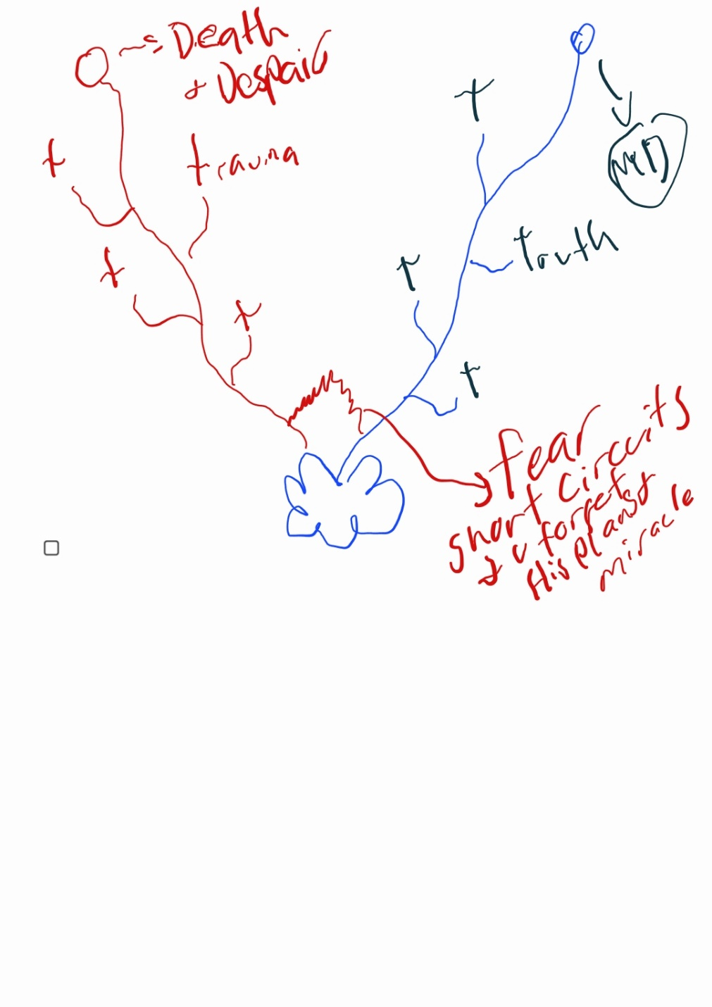

Same as music looking at a cross can be corrupted if you pray to the cross as an object, if you use it as a symbol, with your spirit towards God it is fine. Corrupted songs can be sanctified if you lift them to Jesus Christ Lord of Lords.

They mock our emperor on this planet, let us mock their emperor in the warp and on his plane back =D

We will be as darkness on this plane, blinding fury of fire in the warp!

When they take your meds, you will go manic for Jesus lol

Just go with the flow, stop scanning for signs, be at rest and walk with Him!

Horus will rise in every Astartic Kingdom and make them into Pharisees, getting close to the emperor but turning to their own reflection, most deceptive, most evil

Patientce is key walt, have faith in his patientce

Journal, write down every thought and examine, if you do this they fear their tactics will be exposed! Learning their sop will be very helpful!

Fight the demons that took our beloved, Mic and Ken. They were trying to run from their demons with substances. BECOME a space marine for the one true emperor. Ablaze, shining like the son.

We allowed to use evil tactic against evil (only in warp towards chaos) like Pride damnit etc. Like screwtape forward

Do not chase feelings of elation and inspiration these will come usually before a battle in the battle it will be laborious this is where your faith and resilience is forged for an attorney for all eternity

Looking at a messy disorganized room is like looking into a messy disorganized mind a rather it equals a messy disorganized mind remember you are mind body and spirit clean your room clean your thoughts discipline your thoughts and room

Be disciplined in your body lose weight in your mind clean your room and then your spirit Jesus Christ the Bible lol

Do not become frustrated and rushed with your neurodivergent mind, it runs very fast, wait for others and simplify your life with discipline!



XXX are plan B, the signs will become irrafutable, many will turm to XXX and or spiritualism. Anger and pride will fill them for their version of "Jesus(AC)". Demons know the signs are here and increasing, in their fear they will hurt Jesus only one way, taking His beloved to hell. Plan A is aliens, plan B is XXX, plan C is multiverse chaos BS . Is AC the canon 40k emperor? Plan E is to call the signs cloud seeding, etc, or AI deception causing mass deception and chaos. Lies include Wounded did not die, only a prophet and not God? Signs for Jesus will become irrefutable. False Astartes will rise in the form of XXX, fighting with furious anger (demonic on this planet) we must become slayers in the warp and Jesus love them on this planet and to them.

As we break the very fabric of reality and see the coding of the architect (quantum comp, LHC), a Designer will be the most likely cause to many, they then have to decide through all these plans what it is, in their pride they will turn to plans A-E.

Christ is the light of the world after all, light can become mass

Stop forcing revelation for your own pride, Lord will show you if he wills it, chill and be like Walt

Tesla went mad envisioning the future, do not do the same, he saw spheres talking to him etc.

Everytime the emperor gives you a super effective spell against a Chaos Boss, add it to your memory stones, so that you may quickly be able to use it to attack the chaos boss next time.

As you learn revelations, pride will rise in you, this is how false prophets will come about, fueled by their expansive knowledge of the warp.

I need to talk to Jim! His googly eyes like me lol

I remember I was getting extremely angry (don't ever look at your reflections, do not make provisions for the flesh, and Pride) be a vampire LOL

Think of others pray for others, not yourself, let your love for others guide you.

Christ is King.

Also as you get to the edge of greatness you will be tempted to fall into chaos!

Remember, chill and wait for the record to be done (that's a joke)

Who gave you those dreams to go back to residency? Lucifer or the Holy Spirit???

When looking at God's plan, u must be objective, fear ruins logic and turns into fearful chaos. God is order after all!

Since day has become night, and night day (good is now evil) we must become like the night and shine like the day on our hunt for demons. Reverse Uno the devil, sanctify the perverse, become a dark swarm against pride for Jesus Christ! (Tarnished)

As demonic oppression is rising, many of us need to become grey knight doom slayers to match the darkness of the force rising (just jotting fun ideas down) Be kind and gracious to the oppressed citizen, it is not them you are fighting but the warp. Be a doom slayer in the spiritual realm. Millions of exorcists lol!

God will be very proud of Christ when he returns, so should we. Visualize it. Lift up pride only to Christ, and your fire will burn brightly! Be bold for Him!

When I wrote these things, I fearfully imagine what others will say in my church groups like oh he's crazy, or o he's sooo full of himself.

Ooo look how cool and neurodivergent I am 🤣

Also as your body language affects prayer, so to your surroundings affect mind clean your room!

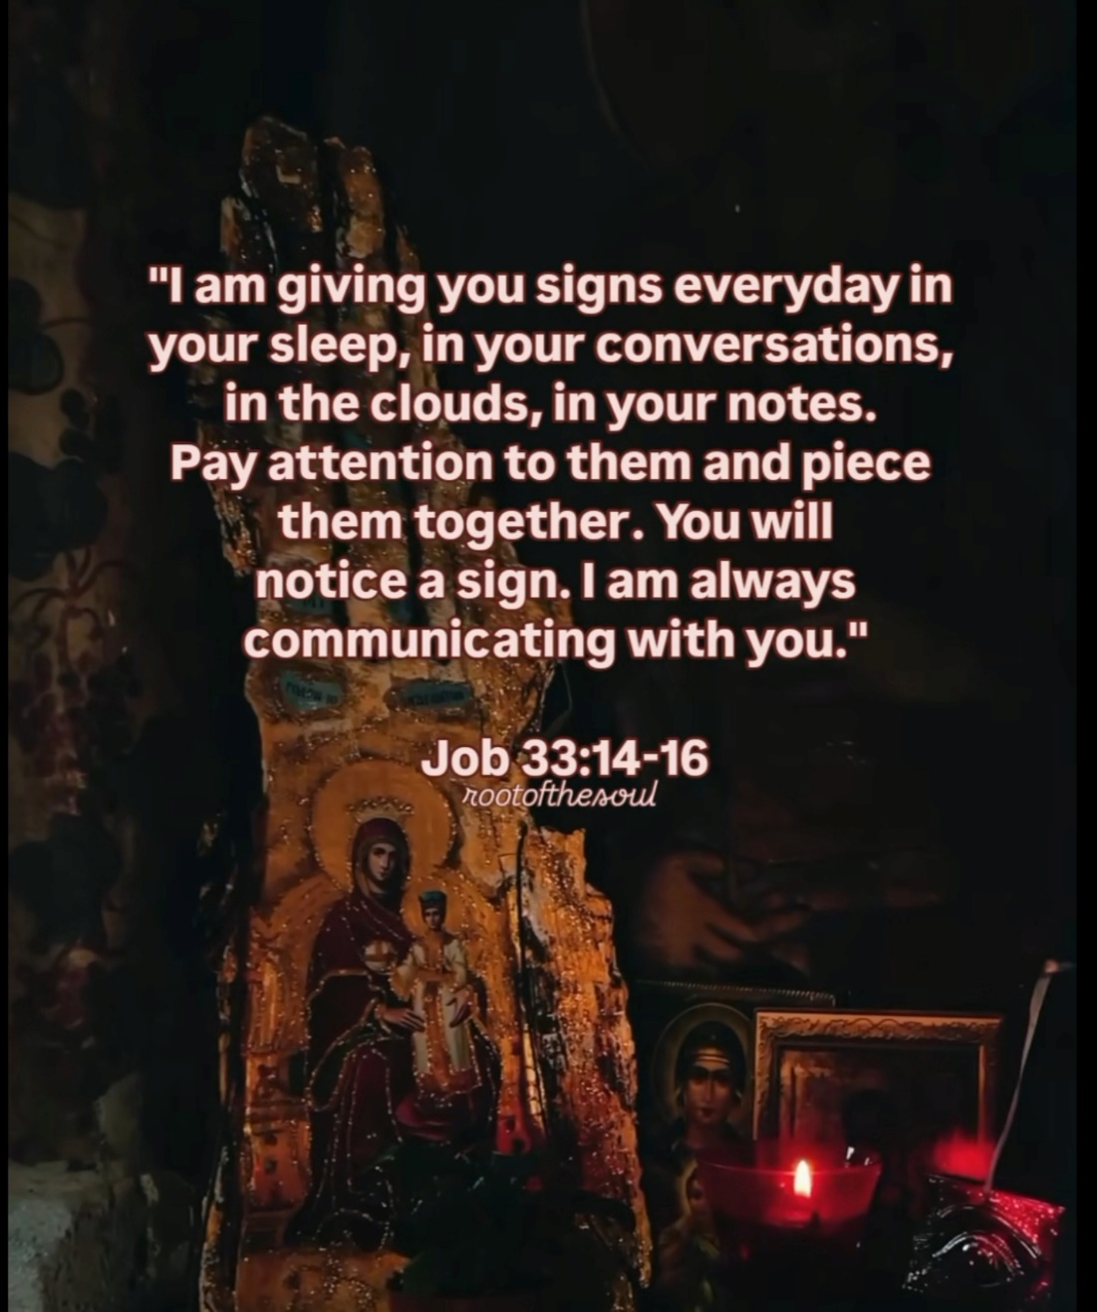

For most of the time always address Jesus Christ never address the demons!

We will be his eyes, shining like the son?

It's ok to not know, u know nothing Jon snow!

Holy fire not burning, frenzied flame madness not consuming???

The canon antichrist will rise like the emperor. Almost indistinguishable from Christ. The deception will know no bounds, as I write the madness, and contemplate, I'm either led by a spirit of antichrist or Holy Spirit. I am either a false prophet or a baby prophet begone spirit of Pride! . Intense fear rises in my stomach as I type this. The same fear that triggers around my mother, oppressed by Jezebel, as she gets angry. It is insanity. The closer you get to God the closer Lucifer (pride) gets to you. It is quite terrifying but I will look up at my Lord Jesus Christ. Visualizing his Majesty.

He wants domination, now he has AI as amazing tools of control. If I were the devil I would write it for surveillance, oppressing maybe even possessing those in power to do my Will.

Antichrist desperately wants worship and love because of his fragile, snowflake, pride. I guess he's a lonely boi who wants to be loved 🤣

This is the Peaceful loving spirit that led me out of depression, anxiety, fear, alcoholism, weed addiction, led me through residency application, residency interviews, got me a residency spot in anesthesia! leading others to Christ, Nic, T, etc. How can it be something evil? How can it be only psych meds? The devil speaks through mom sometimes, my worst stomach curling, palpitation inducing fear is this is all demons. EveryTime, I try and do anything for God I get this horrid fear. Everytime! It hurts my stomach even, same fear.

It is for sure, a demon of fear playing tricks on me, I am, without a shadow of a doubt exhibiting the fruits of the spirit. Thank you Jesus!

In their idiotic pride they showed themselves in video games, they wanted to be worshiped, like those woke people jezebels writing up Lilith lmao

We don't have enough Ram to comprehend all of the spiritual battles and movesets. Need to construct perfect model/figure of spiritual battle for ease of access. Once you know their names and movesets, it becomes very easy!!!

I need to see Thomas !

I need to see TJ

Talk to Christian psych

Be fueled by love for the citizens, leave rage for chaos

Remember they can sense fear, ktf (Kill the Fear)

No detail given to Abraham, he said just go with promises , not what to pack foodz etc

KTP (Kill the pride), KTF (Kill the fear) in you and it dispels for others around you

Be humble, you always need to learn from OTHER PEOPLE that are being used by his Holy Fire. KTP!

Will not call you into disobedience to his word. God's spirit DOES NOT CALL you to go against his word, IE don't check out of your job etc.

You need God's word to know his voice, this sets your steps. You will mistep. Build up your armor and others!

Stop thinking about yourself fool of a took! Think of others, love others around you, it's not about you! You will mistep, but you will always "Rise (Apsahe)"

Pay attention to others, learn from their holy fire! Be humble and learn so that you may teach others IN LOVE you are but one soldier in the spartan army be humble silly. Lord forgive me <3

He gives to Abraham to bless others,to be a conduit for restoration.

Always encourage others

Go where faith is required!

And Abraham went out without knowing where he was going!

It's ok to be sleepy and at peace silly, stop fearing what others think of you. Be your authentic self like Nic said you are better more hilarious sober!

Lol he said there is no SOP for obedience! What a funny coincidence. When God makes something clear, delayed obedience is disobedience!

God bless this man! Metro 5/7/24

Pros and Cons, he said yes smaller than cons, but pros where so much weightier! U need to sit and wait on the Lord! The slayer of Christ, some people will be the sword, some will be the hands, feet, eyes, etc. no part is more important, God has guided your life for a reason and he does so t

For others as well. Strengths and weaknesses will determine your place in the doom slayer of Christ



Whoreus can probably also see the holy angels protecting the chosen, hence attacks on young learning slayers lol KTP!

It's the whole body of Christ as a slayer not just you silly! KTP

Don't make provisions for the flesh

If I were the devil, Demons can give divine revelation from their network, only too feed pride and fear into their patient sending their mental train off the rails. You must walk with Christ at peace in His power armor in the immaterium.

Why is the frenzied flame on May 5th not shared on social media?

You can never learn if you are not and humble.

We wrestle not against flesh and blood, but with spirits and principalities in high places. Don't look at everything around you just keep swimming with the Holy Spirit!

This is fine meme lol

Your final boss to become a “baby prophet” will be Pride, Fear, Cringe.

Bro everyone in your LBS nd GM knowhow crazy uou are, they still love you and are at your back!

I know there are YT angels out there in the web of the immaterium helping me. Just want to say thank you,impraying for yall everyday as well. Stay strong adeptus!

you feel sooo much peace and motivation because you reject fear and fight your spiritual battles with God instead of psych meds! Thank you Jesus, this proves what God has been whispering to you this entire time! What he showed you on physics miracle day. Motivation joy and peace come from your God given purpose, and focusing on that and Jesus. Psych meds assist of course but your foundation is built on faith in the omnipotent power of Christ!

**02Jul24**

You are so spooky until you shine The light on you GDC PDFs LJZs, then we see you for what you really are, a narcissistic snowflake, cowering in your cringy corner. Congratulations you are in the limelight, turns out you are just a self conscious, cringy fool, who is not intelligent enough to learn from his first prideful mistake...

As I prepare for war and the next iteration of the SOP, there is a disturbance in the force...

Spam calls

Calls from Romania

DJs and dad calling me at boathouse

Yo ladies testimony on fear was incredible!

Be victorious, Don't be a victim of Satan!

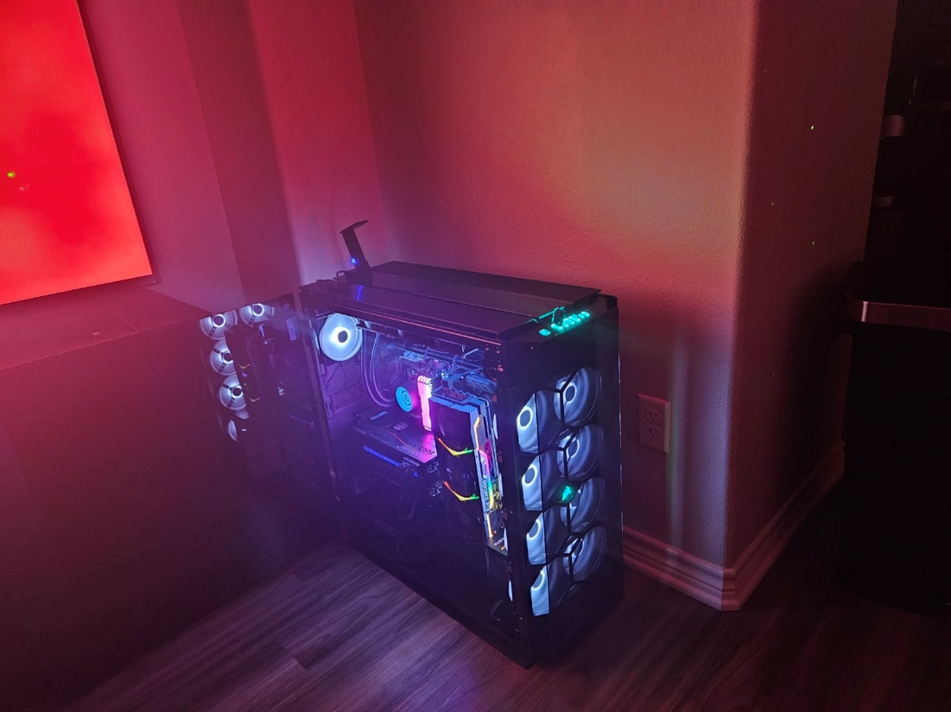

As I write next stream SOP, spams inc in freqeuncy (recorded)

Xxx called you a MD Monk lol 01Jul24

Enjoy the rest always, never feel guilty, Lord has many battles for you in the future, so thank Him for restful time, and be a ravenous warrior in the battles against the demons

Don't worry, you aren't cheating with psych meds, there is no free ride in physics or psych

God will most def take into account your advantages with psych meds and push you to your limit anyways. Thank you Jesus! Testing of my faith strengthens it! I want to move mountains one day plz <3

Thank you Jesus 🙏 🔥 🙏

Thanks you! It feels like I'm in the most amazing dream ever! Even better than anything I imagined =)

Strong men, hard times, weak men, weakt imes, weak times strong men!

Genz were born in the void of society, hard times for their souls, they will fight ww3 of the spirit realm! God bless em, don't

let any boomer take you youthful zeal for the emperor!!!

Confidence is Built on Discipline, not on Talent!

If You Build Confidence on Talent you Become Arrogant!

To celebrate 2 months of me staying staying amidst the dark storm of demons Happy Independence Day!

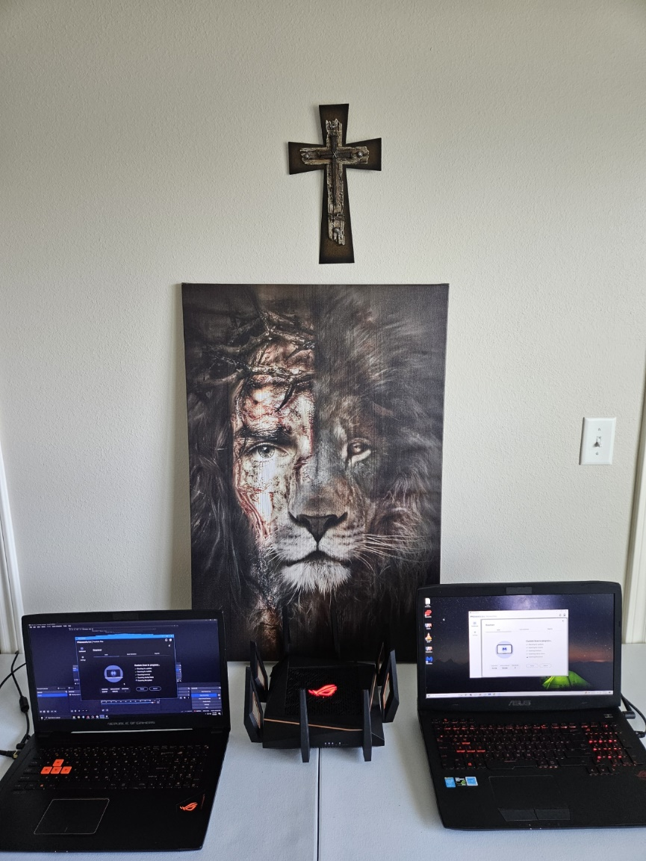

**01Jul24**

Don't tell anyone you're annoying to ever keep that between you and God no weapon formed against you shall prevail thank you Jesus I don't deserve this gift and purpose

The devil is becoming foolish and reckless because the truth is coming out across the world. Just like at the beginning of time is pride will be as undoing is satanic control and broadcasting of his worship has become undeniable His attacks on the good women and men on this planet are undeniable His control on this planet is undeniable remember like from the last right if the devil exists you know God exists The harvest is plentiful the truth of the darkness is being revealed to the world. Those who seek the truth will have mountains of evidence to confirm it igniting exceptional faith in the population

His abhorrent invisible storm only makes the light more brilliant and easy to find by contrast seek and you will find if not enjoy the darkness of the storm

If you go into your childhood trauma

God is doing a reverse Uno and openly mocking their leaders and their disgusting and pitiful state The truth is Lucifer and his plans are utter buffoons when compared to The emperor.

The last Right video clip

They're cowardly panic of the demons is leading them to make critical mistakes The more they lie and cover up the more the truth is shown and revealed and made more obvious what a bunch of idiots May God damn the cowardly pedophile demon soon Amen

I think we're all feeling it and hypothesizing it The coward demon pedophiles will cause some catastrophe before November the 5th like in V for Vendetta because their previous tactics have horribly failed they will do something like they always do to terrorize the population and in turn ask for more freedom and control I don't think it's prophecy it's just basic pattern recognition over the course of history The cowards are desperate and the current lies are failing them it will have to generate a new significant lie and trauma to oppress the population with fear again in order to stir up madness and subservience to their domination

Going on it's almost it's almost boring now that their patterns are revealed for everyone to see you would think these ancient coward demon pedophiles would conjure up a more intelligent plan you would think but as was in the fall at the beginning of time they repeated the same stupid mistake namely pride in the desire to be worshiped revealed themselves to the entire world and now everyone looks to the emperor Jesus Christ

Rise now faux

You're gonna go far kid, take my career and mother, punch your ight between the eyes

Take the hand of Jesus and go on the roller coaster promise you it's worth

Rise now faux

Rise lost frequency

Rise apashe

Just a lil background to my one viewer...

32 yo male with a pmh of HFpEf and Schizophrenia well controlled on quietipine, metoprolol and lasix...

In thought the coward demon pedophiles would leave me alone after I stopped streaming, this was not the case...

Life was good, went to church, med school in Texas, amazing wife doctor, Anesthesiology residency. I dabbled in substances, in my rage I asked to be a demon slayer ...

Lost my career, got heart failure, lost my wife, lost my sanity...

Although painful I learned their tactics.

As a child haunted with the worst visions of hell, worst pain in life so far

Just remember, if you choose the path of the slayer, be prepared to have your worst fears realized, and have everything taken from you. Or just learn from what I learned through excruciating pain...

I've had people follow me threaten me with firearms death threats. Question my sanity but what I did this time is document everything on video or text or any of that I might be schizophrenic but my associates can't all be seeing the same things

So what you are telling me is that Lucifer, the once great prince of heaven now has been reduced to this??? Lmao what (insert lil nas x pic and fluffy sam...

Your legacy will be that of mocking as we laugh at your xxx

The "great dragon" has been reduced xxx

This is the leader you stupid xxx coward demon pedophiles chose. How God damned xxx do you have to be ???



This is your leader...

How xxx stupid do you have to be????

How xxx stupid do you have to be to see the Almighty creator of time and space and be like yeah we can take him .

You likely deserve damnation for such sheer stupidity of pride...

Then you go ahead and REPEAT the same mistake you did at your fall ..

Tell me great dragon? How goddamned stupid are you?

Did your self consciousness kick in? Did ya need to be worshiped like this public ally???

Now ANYONE who truly seems the truth can see the war between you and the emperor

If I were you I would lay low and decieve, you only are speeding up your own demise idiot.

Unless you are desperate for the spotlight because your end is near...

You likely know something's I don't...

-Sent with pure hatred from Romania fueled by the innocent blood you corrupt and spill across our planet

Is jezebel even a thing? Is it just the " great dragon of pride" dressed up as a woman whoring himself out to every man on the planet for control?

U disgust me...

This is gonna be youregacy? Que a bunch of xxx choir drag queens twerking in front of innocent children etc .

U realize the great XXX dragon is gonna be mocked for all eternity in heaven right?

While you rot in hell, we will actively mock you,

I hope you get to hear our jokes/memes for all eternity!

I hope they continuously haunt you while you burn in darkness, despair, and hopelessness

Get ready great xxx dragon. Your time is almost up =D

Psycho puddle of mud

I guess Licu really "enjoys" xxx

Why do I find so much peace from my pure hatred of evil after starting my stream again?

My writings against the GDC PDFs LJZs provides a wonderful (and clearly sane and healthy) outlet and therapy for me!

Make pucker proud bruh



**30Jun24**

Xxx sermon is talking about professional sports players who train their whole lives having the best world-renowned trainers and doctors and everything invested into them training and training and not being able to play this is how you felt this entire time going through medical school now you're finally on the cost of playing praise be to God

The sermon is clearly talking about getting in the game and deploying what you have been equipped with this is exactly where you are at this moment thank you Jesus

Sermon is about also a retired NBA player who retired at 32 He was lost without purpose without the hardcore training He just drove through LA and traffic every day for 6 hours to pass the time he felt horrible cuz he didn't have purpose and identity this is why you felt so bad during the dark times every activity everything you do is a hunger for purpose Amen

The sermon he says no matter the activity whether it's a good thing like becoming a doctor climbing the corporate ladder being the best of your job any of that to be taken away as he says a catastro freaking cut that as was the case for you what do you do then I realize now my purpose is to bring people to the Lord and guide people and spiritual battle and help them conquer their own demons through what I was taught to the glory of Christ only that's the only reason I'm still breathing cuz to save souls Amen

From the sermon Charles spurgeon said you are either a Christian missionary or a Christian imposter

Went to approach life and God minding ourselves that we are sons and daughters of the most high we can approach him with boldness and be a Christian in boldness

Come holy spirit is the short prayer taught by the pastor in the sermon He said to press play on the dreams and visions He has given you years before as you are doing at this moment it literally feels like a dream the best dream I've ever realized thank you Jesus

Fear failure is much worse than actual failure if the gospels are true like Jesus already won everything that that fear represents that makes sense that failure does not bring hellish doom you live in a complain He's already won the battle so we never have to despair Amen

Mission is a gift from above thank you Jesus it's a gift that we often try and refuse to accept because of fear failure this was definitely the case in your darkness

He is the perfect metaphor for you where he took his daughter on a roller coaster that she was super scared of but after going through the roller coaster she wanted to ride again and again she trusted her dad and she liked it this is exactly you you complained with the trials but it's also kind of fun at the end I mean it is incredible to one of these things added to the tool kit and also become closer and more intimate with Jesus as the preacher says

Use an example where he went to his father's work for bring her child to work day and got to see another amazing side of his dad professionalism him being very sharp and in tracking with his colleagues and using the gifts he had this is the same for Jesus as you do works you get to know more and you get to know his character in his love and his power all of that this has been the case for me as well work is tough but it's really cool yeah thank you Jesus

I used to draw spaceships with fuel mapping and stuff, u remember? And dragons!

Be a man worthy of respect, if you need want to be a spiritual warrior and priest, be confident in yourself

and the Lord. Don't practice speeches, God will guide your conversations! I love you Jesus ❤️

This is everything you dreamed as a kid! You are becoming the great person God made you to be ❤️

Thank you Jesus 🙏 🔥 🙏

Thanks you! It feels like I'm in the most amazing dream ever! Even better than anything I imagined =)

155pm

Why are u fearing while working on your bio? You are worried about what xxx will say. Let him say, I will shine for my Lord in humility. Let all the Glory be His!

Bro you have to have healthy pride in yourself as well, if you don’t have faith and confidence in yourself and God, no one will have confidence in you. Like you want your pateints and medical team to respect and have confidence in you

Maybe be like sail



**29Jun24**

<https://www.instagram.com/reel/C8hiXnPA08m/?igsh=NDJ1bG1ydTdmMmIz>

<https://youtu.be/OrAfdoq7xcs?si=hv8IHCRgJJ41l1Dc>

When Satan speaking to God about Job

Pastor said heaven and spiritual realm is more real than reality

We have the temptation to think that the stuff you can't see isn't real, it's all in our head and insanity

This has been the case for you in your Job like journey

God was proud of Job

Make Job proud, don't let Satan have anything bad to say about you. Don't let God be locked by your sins.

Make your Father Jesus HS, ancestors and angels in heaven proud of you!

God was bragging on Job!

God said of Job in heaven, there is none like him righteous on the earth!

Live ur life so that God can brag on you like this to his angels etc.

Satan hates the saints peace, because of his own misery. Devil hates our peace, he is the accuser legalistic spirit. God loves you even if you sin! You DO NOT EARN HEAVEN!

This is why Satan accused you and guilt trips you about your psych meds, through your mother...

I rebuke this in the name of Jesus!

He is the ultimate cynic, he doubts any thing that it is of God, any miracle, like in your case. Cynicism is the essence of the satanic! Like nothing is good, like o Alex is only saying these things to be in residency and tricking etc.

These thoughts enter your mind at a high frequency!

Counseling Job, look man you are the prize for devil and God, God is using you teach angels eternal lessons! New testament confirms this in Ephesians, God uses the church to teach angelic beings about his character and love!

Sometimes no explanation for our trials except to teach angels his divine nature and love!

I think God told GC something,.. this is why he avoids me.

Sometimes there is no reason for suffering, not because of sin, not because of something redemptive, just to show off his divine nature and faithful creature

In the end God used SATAN to make Job even greater!!!

<https://www.instagram.com/reel/C8c7kkOyTGu/?igsh=emUwNmp0MTFvNnhs>

<https://www.instagram.com/reel/C6fN6ckrAoC/?igsh=MXhxMXY3ZmNuZ3Fxdw==>

<https://www.instagram.com/reel/C7YysqkoCD3/?igsh=MWRlMHc2cTdrdG1lZw==>

The EXACT SAME THING happened to you! You loved God, he gave you a wonderful wife, medical career, etc. Satan told God, I only love him for the perfect life he gave me. So God let Satan take everything from me. My career, my physical heart, my sanity, my wife, and now my mother. Everything was taken from you. You were broken but you still turned to God

Satan had power over the weather a great wind in the story of Job. (Htown wind) Was it all around the work? I don't want to fall into grandiosity ...



God is giving you back EVERYTHING Satan took from you and more! What an amazing miracle for me to come back to Anesthesiology residency. Maybe my wife too ... Only the Lord knows.

I will wait years for you. Just give me a sign

Satan HATES THIS WITH ALL HIS MIGHT. HE HATES THIS TESTIMONY. June 27th and 28th miracle, 27th xxxsaid there is likely a way while xxx was praying for you at xxx.

28th while at Dr. xxhouse you got the other text message.

There is hope, it will happen, but God might work it out in another way. He might make the miracle even more obvious through another wrench in the plan. Don't lose faith,x smile knowing God is doing something incredible!!!!

There is a spiritual background to your life right now -from sermon

Shall not the judge of all the earth do right.

**28Jun24**

Let it be done according to your faith!!!

Why does my brain scan for something to be afraid of like if I'm not afraid I'm not close to God or something it's weird. Like the NF song Happy you are indeed afraid of being happy you think is a wrong state of mind why is that it's a very entrenched and ingrained

Look at every task as a video game, get in the flow state of halo

I am not saying this because I am in need, for I have learned to be content whatever the circumstances. 12 I know what it is to be in need, and I know what it is to have plenty. I have learned the secret of being content in any and every situation, whether well fed or hungry, whether living in plenty or in want. 13 I can do all this through him who gives me strength.

Remember, feelings are almost meaningless. Like a miracle can happen and you won't "feel" overwhelming joy etc. Your sould will be at peace and thankful but like you don't have to cry. When reflecting back on divine events you will get overwhelming feelings of love and thankfulness for the Lord. Sometimes when God moves it is such a shock that you can't really feel anything but shock and awe. He is mighty

Also kill the fear of psych meds ,your feelings are like 99% spiritual battles. Psych meds help your mind be organized.

Pucker pops zyn like no tomorrow lol and he drinks

I don't drink and I'm heavy antipsychotics, God is close to you even if you take psych meds

Thank you Lord for your provisions!

<https://www.instagram.com/reel/C8hsXtupwsx/?igsh=MW93ZmtxZ2ZlanpwOQ==>



God is killing the imposter syndrome demon, praise God, he has trained you and taught you over the past 3 years. Through FIRE you were purified and strengthened. Help me to be strong, bold, and humble. Help me to shine for only you Lord, and be the best ambassador for you. Help me to get in flow state and be humble, because when I do enter flow state, I can only enter through humility, pride fear and cringe kills it. To have child like faith, in awe and wonder God has already killed PFC in your life. They try and attack

The boy was made into a man through the Fire.

Also its ok to rejoice! You have lows, God wil give you highs =)



Remember the cowarly PDFs know when God is moving, like they likely knew what xxx was doing and the news. You were anxious last night on the boat, now I know why. The demons were attacking heavily to prevent you from sharing the miracle with xxx. You will get attacked, rejoice, this means God is moving, the demons see, it and they start attacking. God never left you over the past 2 weeks, I think you noticed it. Despair did not overwhelm you, you did not drink or play video games. You stood strong in the darkness, there can be NO DOUBT the miracles that took place over the past year beginning around August DUI. DO NOT EVER DOUBT, take heart, have faith. This miracles on 27Jun24 with xxx texting you at the exact momemnt xxx at xxx was praying for you. Be on fire for him even when it is pitch black around you. The darkness can no longer enter your soul. You KNOW the VOICE OF GOD. Objectively, you are very close to Him. What a blessing this is. To be chosen for miracles and spiritual warfare, and to be a MD for HIS GLORY ONLY. Thank you Jesus for this xMB TRIAL. You are fortifying my faith into a impenatrable fortress.

God is not doing this to punish you, he did this to make your testimony and faith even more incredible and public. To show everyone

The demons of FC always attack when sharing the miracle…

Let them attack I will document, learn, and dissemenate the miracle through social media ;)

Thank you Jesus

We have a lot of people watching Lord, your will be done =)

Faith is not necesarrily something God will magically give you. He helps you train you faith with trials. Ii think this is part of giving us true free will. He wants you to trust, love, and praise Him on your own accord. You are a free agent, you decide what thoughts to amplify or reject. I chose to consume THC and ETOH, which sent me into horrid mania and depression. This was part of my free will. You chose to blaspheme the Lord. Do not blame the devil, you are a free agent after all. Even with the horrid sins and darkness. He takes the darkness you wrought on yourself (and the nondeserving darkness) and converts it to light. He changes the frequency of the darkness, and converts it to light which amazingly, he AMPLIFIES into even more brilliant light. This is his MO, like David and bathsheeba. Christ is a direct desendent of David and bathseeba. Through Davids abhorent sins, billions of souls turned to Christ, as they observeed the repentance of David, running back to His father in repentance. These souls observed the heart of David and his sins. These souls observed the love and mercy of the Father.

Also, like that meme, the spiritual battles will only get stronger. Always retrain your mind to fight this evil using the SOP God gave you.

The patterns are clearer than ever now, its intense darkness (u now do not despair when the darkness comes) then glorious miracle.

HE IS FAITHFUL no matter what. Just don’t ever doubt His guidance especially over the past year. He is always right next to you, even when you cannot see him through the darkness of life circumstances. The devil will tell you are not worthy, don’t have the heart, too weak to fight the fear. This IS NOT TRUE based on your trials over the past year.

Your t

You are in fact incredibly strong in faith b/c of God, you slaughter demons on a hourly basis through the almighty power of God. Thank you Jesus!

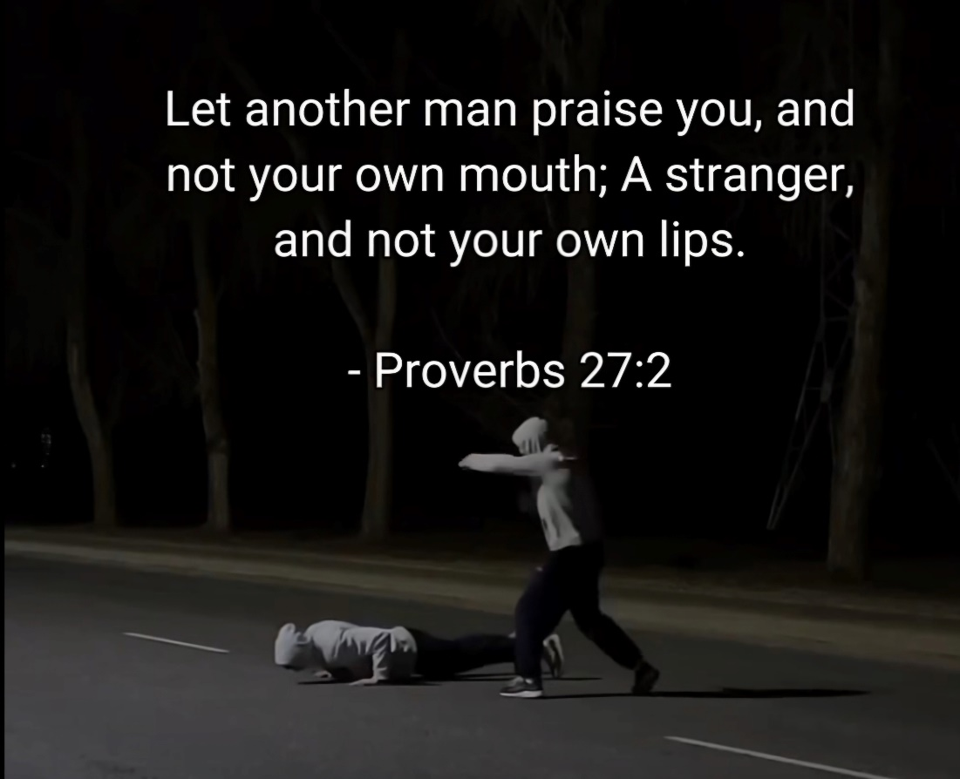

**27Jun24**

<https://www.instagram.com/reel/C37rUdHOB5X/?igsh=MWlvemM3enpwazJsbw==>

You don't need to show off, just be humble, reject fear and self consciousness, and get in flow state. You will show off more like this because you are truly gifted by God! ❤️

Stop assessing your sleep/performance level, the sleep lecture at orientation clearly said we are horrible at gauging our own performance and alertness. IE you have performed extremely well even when tired, like during your physics exam. And vice versa, you are alert and slept but do bad due to anxiety and thought spirals. You are close to a genius when you kill the fear and anxiety and let your mind completely flow! Fear is the enemy not "alertness"

IE thought control/walking in the spirit i

**Slavic Cultures**:

* **Meaning**: While less common in Slavic lands compared to Romanian, the name "xxx" or its variants such as "xxx" (which means "son of the priest") can be found in countries like Russia, Bulgaria, and Serbia. In these cases, it often still has ecclesiastical associations.
* **Context**: Similar to the Romanian context, it indicates an ancestral connection to priesthood or religious service

*From <*[*https://chat.chatbotapp.ai/chats/-O0Px-opG27tncPUvn-V?model=gpt-4o*](https://chat.chatbotapp.ai/chats/-O0Px-opG27tncPUvn-V?model=gpt-4o)*>*

The surname "xxx appears in different cultures, each with its own distinct meaning and significance. Here are a few examples:

1. **Romanian Culture**:

* **Meaning**: The surname "xxx" in Romania is derived from the Romanian word "preot," meaning "priest." It originally served as a title and later became a family name.
* **Context**: It generally indicates an ancestor who held a position within the church or who was a priest within the community.

1. **Mayan/K'iche' Culture**:

* **Meaning**: In the K'iche' (Quiché) language, the surname "xxx" (or "xxx") is associated with governance and council meetings, deriving from the word for a mat used for gatherings.
* **Context**: It signifies a connection to leadership and communal decision-making, reflecting a role in societal governance.
* stical roles.

Remember the miracle of your physics 2 exam, you stopped worrying about your psych meds and realized that you work the best when not at fear what so ever. This is because you enter flow state

Xxx said he stopped drinking a bunch of caffeine so that it doesn’t trigger anxiety, he said its better that he is tired than anxious, I believe this is what you were doing on the physics 2 miracle exam

27Jun24, xxx and xxx were led to fast today, the same day xxx is going to try and resolve your TMB issue.

xxx

90% of your fear and anger comes from thinking about what others might think of ou, only imagine what Jesus thinks of you. Make Him proud =) <3

Entropy also affects the mind, like in the am you need to go to God in prayer, and reorganize your mind on Jesus and His plan for you.

You must do this continously, throughout the day. The PFC always is trying to attack. Reject and be at peace. Seek peace not stimulation.

To become the saint that God wants you to be, he will teach you and help yu cast out fear COMPLETELY out of your life!

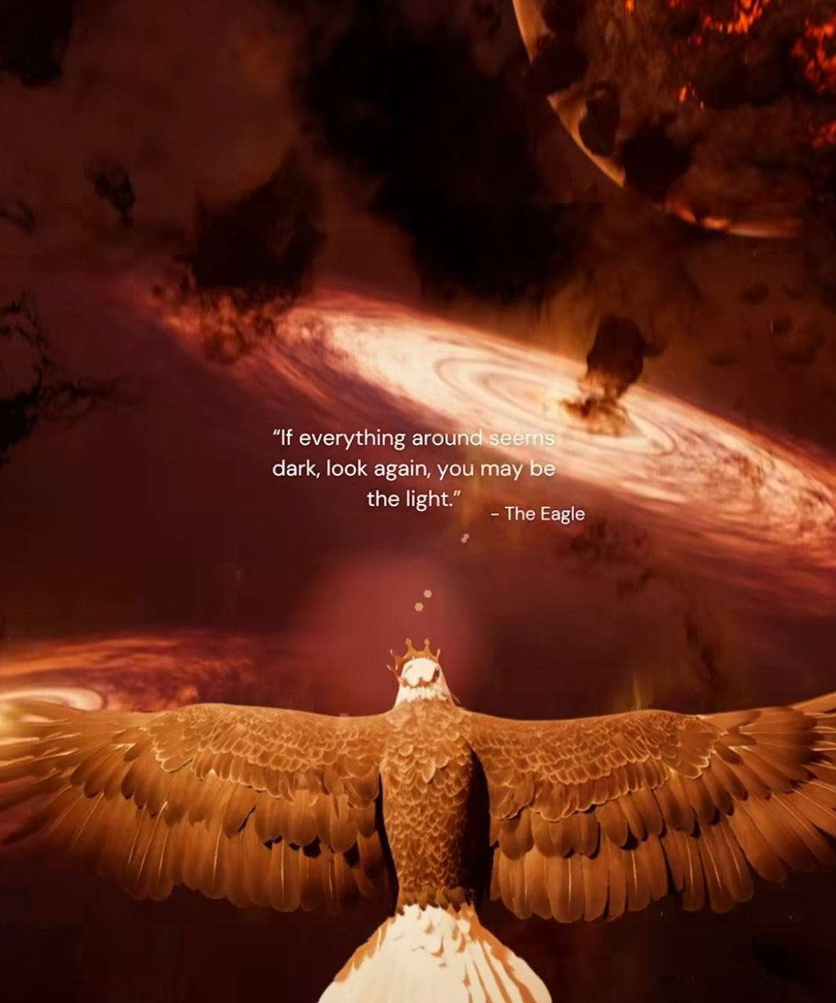

**27Jun24**

<https://www.instagram.com/reel/C37rUdHOB5X/?igsh=MWlvemM3enpwazJsbw==>

<https://www.instagram.com/reel/C5hHHxShYSx/?igsh=YmdnMGQ3M2k4dnR0>

<https://www.instagram.com/reel/C8IKqrmRY7E/?igsh=MW04Yml4aXdxazVu>

Rejoice! You will have a month to improve and rest!

**25Jun24**

Per the

Orientation

Whatever happens, if I have to wait a year in xxx that’s ok, per Dr. xxx, I WILL have a spot! Worst comes to worst, you can work in xxx, and explre creative ideas regarding VR, starting a company, etc. You can further xxx here in xxx at the medical school. This would kinda hurt Lord, I am kinda tired of waiting. But YOUR will be done on earth as it is in heaven. YOUR plan is ALWAYS the best. Please forgive me for questioning your goodness and faithfulness and EVERYTHING you have done in my life. Whatever happens I have you Jesus, and that’s enough.

This is just improving your already amazing and divine testimony (ie its all God helping me)

Please forgive me for my sins Lord. Whatevr you do stay close to me. Walk with me closely, I love you more than anything in ANY universe. Forgive me for questioning your guidance and teachings. I am sorry for questioning your spirit. Please forgive me <3. Thank you for being so loving. Help me to stop being double minded about your joy and love. Please above all else, do not let me despair, this breaks our loving relationship.

Please, plesae, please, just not despair, in Jesus name. Never never never take my hope. My hope, joy, and peace does not come from psych meds, but from you. You will get tired, you cannot be in a state of elation all the time silly, you cannot have infinite energy (unless God calls u to intense battle) but generally rememebr ou are body mind and spirit.

You attacked the kingdom of Satan, you will be relentlessly attacked the rest of your life. Do not be surprised when demons try and attack.

You have to stay in the same mindset as you were when you were writing FIRE in May. The demons wont ever stop the attacks. That’s ok, I like the action. Let me fight voraciously for the kingdom of God. You wrote the SOP with God's help, now u MUST apply and remember the spells God taught you at this time.

I need to restart the bombardment, the coward demon pedohiles are attacking my career and mother and father.



Good morning boys.

S)

**24Jun24**

The determination.

Why Lord, why add this trauma right before I start. Why? WHY???

You must make a way Lord…

Be a got dang man brother 💪 💪 💪

Always swim in your lane, when you compare you exit flow state. Also when you worry about psych meds you exit flow state. Remember your thoughts need to be addressed by God and the techniques he taught you. Ie depressive thoughts about current task, learn it for God, hack your brain =)

Focus on your own demons, you are not everyone's savior, Jesus is, not responsible for others reaping, don't sow what they reap!

God fast tracked you through evil attacks to prepare you for residency. It is working! Ty Jesus, help me to stop doubting and realize we are in LOTR adventure!

Praise Him when your excited in the am, praise Him when your tired. Your body and mind will of course go through ebs and flow depending on food, water, work, psych. That's ok, rest in his peace always. When bored contemplate His majesty =)

God is giving you another miracle, He is building your faith more and more. Lord I am kinda afraid, what in the WORLD are you preparing me for? Let me never fear or despair. My testimony is and will be incredible. Maybe this is why the devil is attacking so hard, and why God is permitting it.

He helped you conquer extremely powerful demons of pride, despair, and fear. The Lord is making me stronger and stronger everyday. If he helped you conquer literal demons will he not help you in doing your job?

Others have alcohol they run to and are ok to use. You have psych meds, He has given you many good psych meds. Be thankful, don't try and attack fear with psych meds, go to God, he ALWAYS HELPS! He has helped you this entire time with your psych meds, stop being double minded and put this fear to rest forever. You DO NOT have to keep reviewing the dead. It shall be done according to your faith =)

Do not be double minded about anything! If you think something in faith that brings you the peace of God, DO NOT EVER QUESTION IT!!!

Remember you are a warrior for God, you will seem “different” from others. You now only think in the spiritual realm. And that's honestly amazing, thank you Lord. Help me conquer my own evil oppressions and become strong to help others with their own afflictions. Ty Jesus!

**23Jun24**

Kirk says that he feels the rumbling of revival too, awakenings always occur when under persecution

Also from Fight club, although it sucks overall, Tyler was correct about men being demasculated, he said verbatim that the previos wars like in ww2, gave man purpose and they went to war. He said ww3 will be overall spiritual, like you said to Skylar.

God says he cuts and prunes to bear the best fruit. This is exactly what happens in our Neural Pathways of thinking. Cut down evil/sin and diabolicaly despairing pathways at the root, and train your mind to go down the path of light that God is teaching you. You NEVER EVER HAVE TO DESPAIR! Christ has one already!

You are becoming a Christian wizard, how cool is that!!! No one said this training would be easy, but I believe you have gone through the most difficult portion of training, namely the despair and pain of loss. But praise God, he is working very closely and powerfuly with you!!! 💜💜💜

Like any AHDH Bipolar Schizophrenic Neurodivergent mind, it will take you awhile to get started on a task but once you do you do it very well! TY JESUS

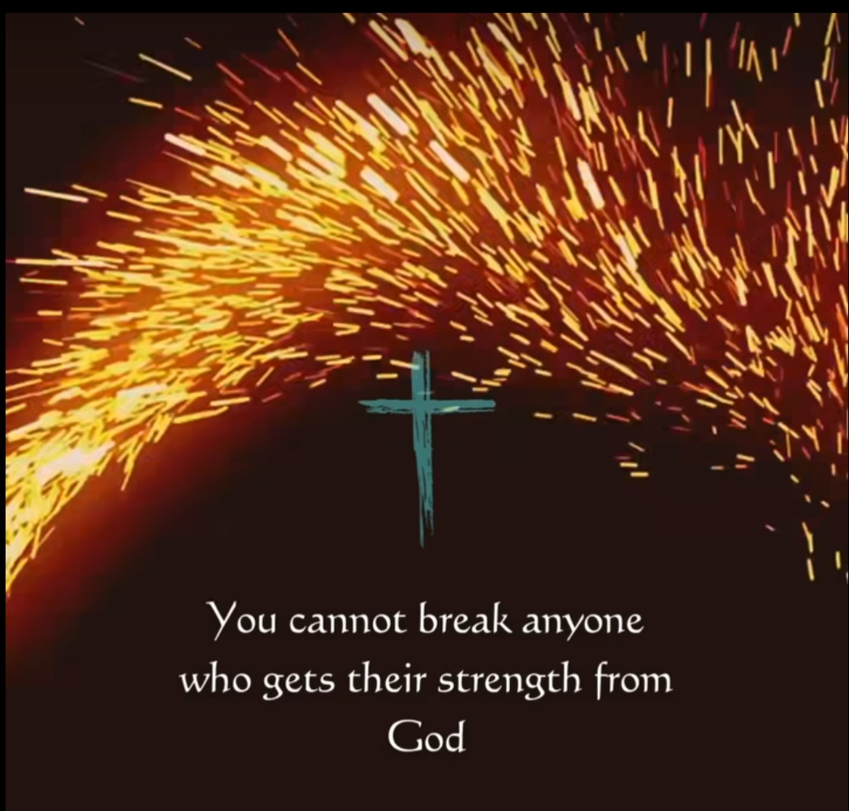

**22Jun24**

Remember the devils strategy is not necesarrily Sin rather it is despair, faith by works, despair is the fear and depression of hell itself. Jesus already won the war, you have a seat in heaven, no matter what!

You will sin, this body is wretched, do your best but do not despair! To despair is to worhsip the devil, you don’t EVER have to despair! EVER, I think your problem is whenever anything does not go perfectly you instantly flash into the fear of Hell that evil traumatized you as a child with. Do not ever despair

Also stop thinking this hellish fear will go away with psych meds. They help for sure but they help you fight the spirit of fear with Gods help and prayer.

Like I have noticed that the hellish fear triggers even with mundane tasks like brushing teeth or doing educational modules or whatever fill in the blank brother.

Your mind was very sick and traumatized. You are developing better neural pathways/habits/ thoughts through the guidance of the Holy Spirit. Praise God!!!

Despair loses! Today there is only hope!



Help me never to doubt your faithfulness, you did not bring me this far, write this incredible testimony, to drop me at the end!

xxxis praying, xxx, xxxxxx and xxx are fasting, do not fear. God is already moving. Lord help me to be patient, continously cut down the fear pathway when the thought flashes through your mind.

TY JESUS!

Nothing else matters!

Min max everything!

Have a goal, like finishing the online courses, and focus and complete blasting away with all your heart

Anything you cannot control, don’t every think about after you do your part, leave it to God, ie waiting for TMB

Remember when you make an error with your perfectionist ocd, your enraging response or fear or frustration is YOUR OWN response, its not the fault of the program, the profram might be in error but YOUR RESPONSE of stress etc is YOUR problem, fi ur neural pathway of thinking! BRAIN HACK YOUR WEIRD BRAIN heeh

ALSO TO ENTER FLOW STATE YOU HAVE TO STOP THINKING ABOUT PSYCH MEDS, THIS IS WHY TIME JUMPS WHEN YOUR AT PEACE AND NOT WORRYING ABOUT ANYTHING!!!

Go slow at your own pace, you have a fantastic mind, its special and might need more time but you learn it VERY well and forever. Do not ever compare yourself to others pace. You are "different"

Be at peace with your pace, do not despair ever!! This is common trick of devil.

**20Jun24**

Nothing else matters!

Why was I so stressed last night? Because you spent it with a covert narcissist xxx . You were angry and stressed because he was talking over everyone. Anytime someone would start to say something, he would hijack the conversation preventing anyone else but him from shining. I remember vividly xxx was starting to talk, and xxx tried to hijack and xxx just kept talking over him. Help me to Love him Lord. If it gets worse, give me the words to speak to him. I want our squad to be united in the love of Christ. You are also stressed because you doubt your gift of discernment. This is why ur so good at poker. I think God was teaching yet another lesson 😅 when you have this spirit of anger and frustration, address it head on with prayer, bring it to God, he will dissect it apart for you! Do not distract with music, yt, ig. Do not ignore the tormenting spirit. Cast you gaze upon it and tear it apart with the word of God 💪💪💪

Love love love on xxx, do not enable his narcissism, but love him.

Also sleep! Sleep always helps hehe, the demons get bored and they leave. Weak willed goddamned coward pedophiles!

See xxx, it was painful and stressful last night, learn to run to God when the spirits come, not psych meds!

God this LOTR adventure is amazing!

Xxx is praying for the xxx, xxx and xxx fasting, xxx is too,

This is where I'm supposed to be, stop doubting. He WILL MAKE A WAY

Your of had a yt video about being a spiritual warrior!!! How many more signs u need???

Work on clerical stuff from 330-530

Dinner with xxx

Gym?

Thank you Jesus for fighting fear for me =)

U da best!

If God helped you literally cast away Luci and Jzbel, he might be able to help you do the mundane boring parts of work too (emails, notes, studying, etc =)

Relax, you conquered residency with Gods help before, now you are stronger than ever!

I don't know the future but I know the one who controls the future



**19Jun24**

Nightmare, 2 demonic women dressed in black staring at me from a distance. Woke up through the power of my mind and cast out demon then went to sleep lol

God damned Coward demon pedophiles!

Demons don't want people to sleep about psych issues, fear and dread come upon others if I reveal I am bipolar, because it is indeed a spiritual war, and you are revealing the spirits of fear, depression and pride

Even if the demon model isn't perfect it produces good results, like I could whisper in your ear horrible things about yourself for awhile, build the neuronal pathways of depression in your mind, then you would ruminate and run through this pathway yourself

<https://youtu.be/lEtv-K0ikwc?si=5lkba90YO_FnCCzH>

Amazing book recommended by xxx boundaries

A god-given goal is something that you cannot even think about not doing in your life it is a passion

Somebody sowed evil and wrong person reaps mom and dad

Irresponsibility you sow you will reap pain. It is like the law of gravity  This can be suspended by God's intervention… ie ur xxx with God's help.

Accept what you can't have and appreciate what you do have and can have!

Gratitude will multiply and amplify joy

Ownership of depression and anxiety, even if you are victimized like you were as a child, it's your responsibility since it's your problem of the soul, you feel the pain, it's your responsibility to go to God for healing and trust.

Whatever is on your property, give it to God. You have to exercise your atrophied spiritual muscle through grace.

Even though things are by grace, you have to work for it, it is an active hungering and thirsting for Jesus and righteousness.

Don't take guilt

You will disobey your disfunctional parents Jesus said and you will feel guilt, your fam will disagree with you

Don't stop your growth when you feel guilty

I don't know what the future holds but I know the person that controls my future.

Fear of the unknown will scare you!

Don't blame anyone or anything for your misery. This gives them power over you. What do I want from you that brings you misery. Is it approval from them etc? Like maybe you and Evan wanting approval, be confident in your God given skills and gifts. Your misery is your own response, build walls around your mind and spirit!

If I feel guilt you are not hearing the voice of God, you are hearing the law!

We interpret guilt as God speaking to us, but often times it's from the law of sin and death and condemnation and fallen conscience that we get from our parents. As Cloud said, you have to break generational curses that are sometimes handed down for 10 generations!

You can feel guilty for doing the right thing… ain't that the truth! You can feel guilty for growing up! You can feel guilty for saying no. Some feel guilty for existing…

Hebrews said Christ died to cleanse us from a fallen and evil  conscience. When we get free from guilt there is no condemnation! Like Cloud literally says is this guilt you hearing the judgmental condemning voice of your mother/father? Like your mother condemning you and spewing guilt all over you for your psych meds? I cannot believe how much pain and sorrow she has caused me. The feelings of inadequacy, anxiety, and fear. But it's ok, I may have been victimized but God showed me unimaginable truths and strength.

Then we can stop focusing on guilt and start focusing on the real problem which is always a breakdown in love, perfect love casts out all fear. I do not understand this fully, Lord reveal it to me please. Do I not love myself enough to give myself a break? Cloud said to grow you often have to be selfish. Being selfish in a balanced manner is not a sin. You have to take the log out of your own eye to help others. You have to be strong to give strength to others. You cannot be drowning and try to help others. Lord please help me conquer this feeling of condemnation, anxiety and despair. 🥺 Please… once and for all… just remember that psych meds do not help the spiritual war of depression and fear. Address the fear with God and prayer. The meds help your mind be organized but it is God who fights for you in the spiritual realm. It's ok to pray more and more when you are weak. The demons will flee.

Whenever you feel guilty find the problem, mother's voice, our own self centered wishes etc.

You will break the traditions of your disfunctional parents when you begin to love Jesus said.

Jesus said, I did not come to bring peace but a sword, and a mans enemies will be those in their own household.

We dont get better in a vacuum, friends and family can help, like they have been, this is what I have experienced through all this pain. We are the body, each joint supporting each other, when each part works well, the body of christ becomes stronger. As Christ is the head. The Titan of christ is growing as the darkness approaches! David says he loves those who loves God. He is making his choices of friendship. I am indeed drawn to strong christians like xxx and xxx. You do indeed chase after their God given spirit. Rejoice in the guilt. You say no to someone, and you cant sleep at night? Praise God, you are growing and maturing as a Godly man. After you have disappointed the legalistic parent you transfer your love and support to the body of Christ. Taking out the legalistic voice in your mind and replacing it with Grace.

After we deal with our own issues of depression, anxiety, pride, anger, the great comission says to go out and help others! Comfort others with the same comfort you have been comforted with. Which in your case has been boundless. Once you become strong, and mature, and developed those boundaries around you heart and mind, you will want to go and help others with what you have learned. The grateful heart you develop will still have limits, like the samaritan did not adopt the one he helped. He helped as long as he had need and moved on. This is true in your own life on many occasions with friends and parents. When you build boundaries, and are no longer can be abused by others and spirits, you will want to find the oppressed and abused and help them. This is very true in your own life.

Lor it is painful as you remove the trauma shrapnel through my heart and soul and heal my soul. I noticed my soul is becoming more joyous and peaceful. The process is painful but you are healing me, the Great Physician, Thank you Jesus. Please finish your work rapidly, I want to go and heal others, but I need to be strong and complete in you. Build up walls around my mind and soul please. Help me not to fall back into the trauma and depression pathways. Please kill and bury the spirit of trauma, depression, and fear. Please deliver the final blow, and let it never resurrect. In Jesus name…

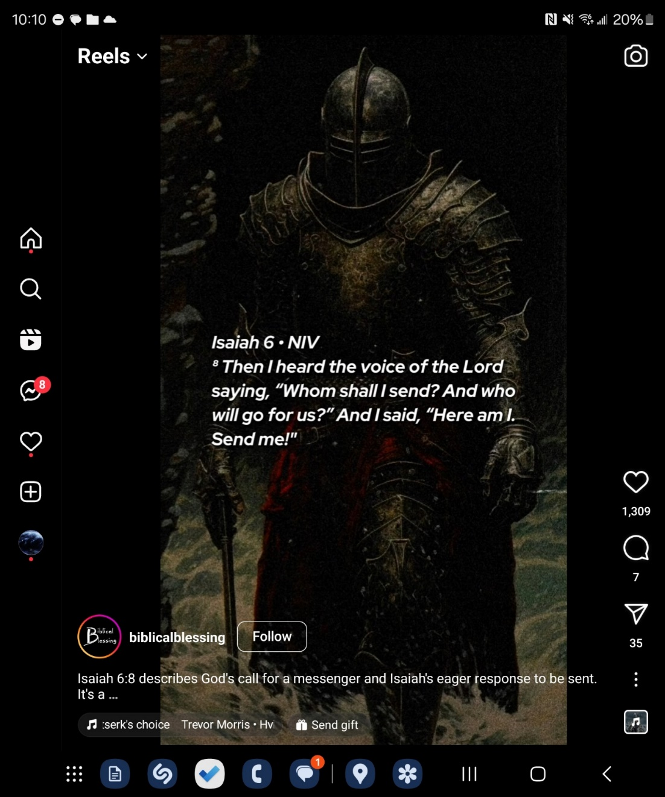

**17Jun24**

<https://youtube.com/shorts/e4-I4nmNAHE?si=BTT7RGZRtNHFA6Av>

xxx, I just wanted to take a moment to express how truly grateful I am to have you as a great friend. Your unwavering kindness mean the world to me, and I cherish the bond we share more than words can express. Your presence in my life brings me so much joy, laughter, and comfort, and I am endlessly thankful for your friendship bro. I want you to know that I am here for you, always. Whatever challenges you may face, whatever dreams you may pursue, I will stand by your side, cheering you on every step of the way. Thank you for being the incredible person that you are and for enriching my life in ways I never thought possible. You are not just one of my great friends; you are family through Christ, and one of my greatest blessings. Here's to many more adventures, laughs, and memories together. I love as a brother in Christ more than words can say. Have a blessed week bro!

-xxx

**16Jun24**

Xxx sermon

Pain plants the flag of truth into the fortress of the rebels heart -CS Lewis

Be tied to patience as pain increases

Quit believing man and start believing God

When everyone tells you to give up, you have to be a bear -GC

They laughed at Jesus when he said he would raise the little girl from the dead.

What the media says about you man is untrue

You are not incompetent, not a bumbling idiot

Be a man of God -GC

Don't stop believing in Jesus faithfulness

Douglas MacArthur

“Build me a son, O Lord, who will be strong enough to know when he is weak, and brave enough to face himself when he is afraid; one who will be proud and unbending in honest defeat, and humble and gentle in victory.

“Build me a son whose wishes will not take the place of deeds; a son who will know Thee—and that to know himself is the foundation stone of knowledge.

“Lead him, I pray, not in the path of ease and comfort, but under the stress and spur of difficulties and challenge. Here let him learn to stand up in the storm; here let him learn compassion for those who fail.

Build me a son whose heart will be clear, whose goal will be high, a son who will master himself before he seeks to master other men, one who will reach into the future, yet never forget the past.

“And after all these things are his, add, I pray, enough of a sense of humor, so that he may always be serious, yet never take himself too seriously. Give him humility, so that he may always remember the simplicity or true greatness, the open mind of true wisdom, and the meekness of true strength.

“Then I, his father, will dare to whisper, ‘I have not lived in vain.’”

This is what God wants to build you into. No wonder the trials are like a raging fire.

**15Jun24**

You had amazing dreams, slept 10hours, full REM cycles with Ser

You need 12 hours after taking Ser for a full sleep cycle since you also generally eat after taking Ser. I feel amazing this am, no fear, etc, joyous, thank you Jesus!

Take Ser 12 hours before u need to wake!

Dreams were amazing too! You were basically at the cloud station in StarCit which was run by xxx, amazing fun dream ❤️😎💪😊

Ty Jesus for this day!!!

U need to develop strict sleep schedule for you special mind hehe



**14Jun24**

Put to death the trauma that Christ put to death!

Whether it's traumatic memories of xxx, your sins he bled for, or your decisions to cut off mom. Make a decision under his protection and guidance and stick with it!

DO NOT EVER BE DOUBLE MINDED ABOUT YOUR STEPS OF FAITH!

Nu Dezgropați Morții

Talked to xxxand xxx from car rental. He and xxx see the exact same spiritual battle happening everywhere, both have mothers similar to your own. xxxs mom is bipolar alcoholic

**11Jun24**

When u texted mom after all the stress and anxiety, you were thinking about finding a bible study during the week.

within A couple of minutes you found xxx ministry, got free Chick-fil-A and worshiped and heard a sermon about being broken and being used by God in a very special way.

Psalm 16 1-2

What is your refuge? When He is your Refuge, you can find peace im the midst of hell itself.

Trials are there to teach yoh something about God.

There is nothing you can do to lose His love, because there is nothing you can do or did to earn His love!

Generational changes ,”your legacy does not have to be your parents”

**09Jun24**

HFBC sermon

When in the will of God, amazing fruits will come (like in your circumstance so reject the fear of mania etc) God has produced amazing fruit through you

Sermon

We are people on the move =)

Dont think you are not too important to take a break!

We all need time to reevaluate who we are, our purpose, and the person we are becoming.

There are always other people who can teach you be humble!

Hi!

Regarding the tormenting spirit you mentioned, I wanted to share my own experience. I haven’t shared this in its entirety with anyone because I was always afraid someone would label me as schizophrenic… I believe this fear is what prevents many Christians from opening up about their spiritual and psychiatric battles.

Since I was young, I had horrible thoughts stemming from a false image of our Father as a vindictive, sadistic, and abusive one. This image likely stemmed from my father who was not Christian at the time and was practicing very dark witchcraft through eastern spiritualism. My demonic attacks of depression and fear started at the age of 10 when my mother took a bunch of sleeping pills to try and commit suicide. My father didn’t care, he left her to die in bed and went to work. I was left alone day and night with her catatonic body praying that she would wake. I thought she was going to die, this is when demonic attacks started in my life. She did wake but a dark cloud descended upon me and stayed with me. After this trauma I was convinced that I was going to hell. I had excruciating visions of eternal darkness and pain. I was also convinced that I was the antichrist.

When family and even xxx LBS teachers tried to console me with love, it would only make the depression and anxiety worse. I kept imagining that I would lose them for all eternity, and never see them again in the void. Because of this, being close to loving family and xxx teachers actually made the fear and depression worse. Being from a Romanian family, they did not believe that I was depressed at the age of 10, and they did not believe in psychiatric treatment. This torment lasted for about 2 years. To this day it was the most painful experience of my life. I believe that this ultimate fear is the very same fear demons have. I believe this is why they trembled at the feet of Jesus begging Him to not start their torment prematurely. As a child they haunted me with the very same fear they must continuously live with. I share this experience to show the tactics of demons through trauma against young innocent children.

I always questioned why God allowed these demons to torment me as an innocent child. I know now as a medical doctor and psychiatric patient; it was to teach me spiritual warfare and the tactics of demons. Xxx has taught me that even with the darkest of trials, our Father is lovingly trying to teach us incredible ways to conduct spiritual battle. Both for our sake, and so that we can help others who are fighting similar tormenting spirits who spout the same lies to our beloved brothers and sisters.

More recently, a couple of years ago, I was finally diagnosed with bipolar and had to be admitted to a psych ward for mania. Although difficult, God also helped me further understand the physical and spiritual side of psychiatric conditions. I had the privilege to speak and give counsel to fellow psychiatric patients who were hospitalized with me. I am still friends with many of them to this day. As you mentioned, the spiritual side of these conditions are very real. Similar to my own experience, most if not all patients I spent time with mentioned dark spirits that they see and hear that started haunting them as children. Many of them had horrible trauma that opened dark spiritual doors to these tormenting spirits. To this end, through medication, reading the bible together, and prayer against their demons by the might of Christ, I saw incredible healing take place.

As we are body, mind, and spirit, medication also plays a beneficial role when prescribed correctly. From my own experience antipsychotic medication helps me sleep at night and stabilize the frequency of my somewhat unique mind. This gives my physical mind the much-needed mental rest from the constant spiritual warfare that psychiatric patients are especially sensitive to.

All this to say that many instances of psychiatric healing requires helping the body and mind through things like exercise, healthy diet, and psychiatric medication when needed. For example, someone can be triggered into a panic attack stemming from a spirit of fear simply because they are dehydrated, haven’t eaten, or haven’t slept well. This is why demons like to attack us when we are tired, hungry, or stressed from a long days work. This is also why Sundays are set aside for us to rest.

In addition to helping the physical side (body and mind), just as critical, if not more important, is addressing the spiritual side. Taking every thought captive and examining it to see whether it is a lie from evil or truth from the Father. In addition to medication, dissecting every thought through the infinitely sharp surgical scalpel of the Bible is what delivered me from the spirit of fear, depression, and mania. The science of medicine shows that the combination of medication and therapy is better than each on its own. As a Christian I find this to be true, medication in my case helps tremendously, but Christian therapy is the core of healing. I do believe people can be healed through Christian therapy alone but I also know God heals through medication as well. Furthermore, I used to torment myself and believe I was evil for having to take medication. I believed that I was a weak Christian for having to take meds and that I was faithless. I know now that God can leave a thorn in the flesh to keep us humble and to be able to empathize with others in similar situations. I hope that Christian psychiatric patients on medications can reject this same diabolical fear that I had.

Thank you for letting me get this off my chest lol. Sorry for the long winded response.

I do have one more prayer request. The aforementioned suicide attempt by my mother stems from her own bipolar condition. I likely got my psychiatric condition from her lol. She had been going through cycles of mania and depression since 2002 (when I was 10). She believes that all psychiatric treatment is from the devil. She torments me for taking psychiatric medication and speaks horrible fear and anxiety over me. In her mania she recently laughed at me saying that I did not even know who my real father was. I recently learned that she has unrepentant sexual sin and abortions in her past. I know this is another spiritual attack but it still wounds my heart very deeply. I know she knows Christ but in her mania she flashes into a prideful, scoffing rage that I can only liken to the spirit of Jezebel. She recently left her elder LBS at xxx(she was part of this LBS since 1998) because of her hatred of a man who was in authority over her (her LBS teacher). To this end, she continuously insults my father (who is Christian now). In her mania she seems to hate him, calls him horrible names. She tells him he is a stupid, weak willed coward, who only is good for making her money. From personal experience, in mania, you are very sensitive to the spirit realm. In her manic state she seems to enjoy the prideful spirit of Jezebel, she relishes the power, anger, and domination over men that the spirit gives her.

This spirit has been tormenting my family since I was a child. As we try to convince her to accept treatment and go under the authority of a psychiatrist (and her husband) this Jezebel spirit manifests with increasing frequency and amplitude. I have never seen her this bad. She recently physically assaulted her 90 + year old, blind brother in law. She recently threatened to physically assault my father. I was in Romania last week attempting to bring her back to America to be with her husband and family to heal. She was arrested at a hotel lobby in Romania and taken to a psychiatric facility. She threatened to sue as a American citizen and they released her. She is harassing her friends at their home at 1am, people in the neighborhood had to call the police multiple times because of her erratic and dangerous driving. Somehow she escapes the police and psychiatrists time and time again. My first day there, after a beautiful day at church (02Jun24) I thought I was making progress with the mother I love deeply. Later that night she started speaking ill of my father and calling him a cowardly weak man. After I commented how this is a wrong for her to do, she flashed into rage calling me a man possessed by demons, and that I should let her be Jezebel. This is the same day she mockingly told me that I didn’t even know who my father was…

Please please please pray that she accepts psychiatric treatment and that she rejects this spirit of Jezebel. There is incredibly strong evil haunting my family. Please pray that my mother repents and heals body, mind, and spirit. I do not know my mother anymore. I do not recognize her in this state. She is the best mother I could ask for when she is not manic. The more my family prays that she gets treatment, repents, and rejects this evil spirit the stronger this Jezebelian spirit manifests. She calls me at night speaking hauntingly diabolical things over me. The next day she says she cannot remember ever talking to me…

I am sorry for going into such dark detail but I wanted to convey just how serious this demonic attack is. Even now, as I write this prayer request against this evil in our family, powerful spirits of fear and dread are attempting to overcome me. Our family honestly needs a psychiatrist and exorcist lol. Please pray that myself, father, sister, and brother do God’s will without fear in an attempt to save my mother from hurting herself and others.

Your prayers are desperately needed again! I want to thank you for giving up your time and energy to help me and my family.

Sincerely,

xxx

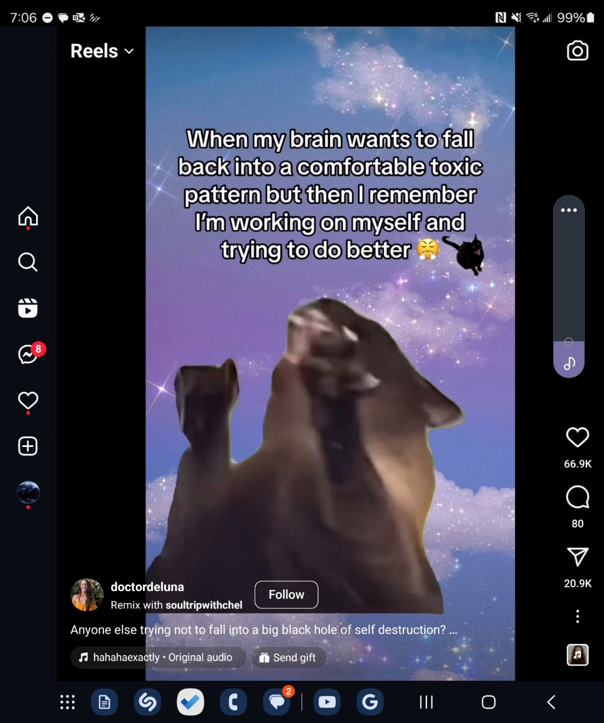

**07Jun24**

Slept at night after Romo flight

Dream of a narrow green road through grasslands that were light up but it was night. Saw the moon being eclipsed by another planet. Such wonder and awe in The starry sky!!!

**04Jun24**

Remember to accept the good gifts he gives you. The Lord will let you suffer for a little while to grow but he also gives good gifts <3

Why do you feel guilty for being happy? Like something is wrong if you are not worried about something. The cowards are indeed tricky

When good Men fail to address evil…

Also don't seek glory, ur Father and bestie knows, that's enough ❤️

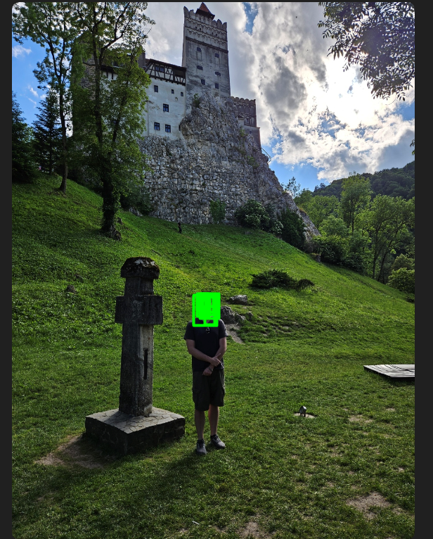

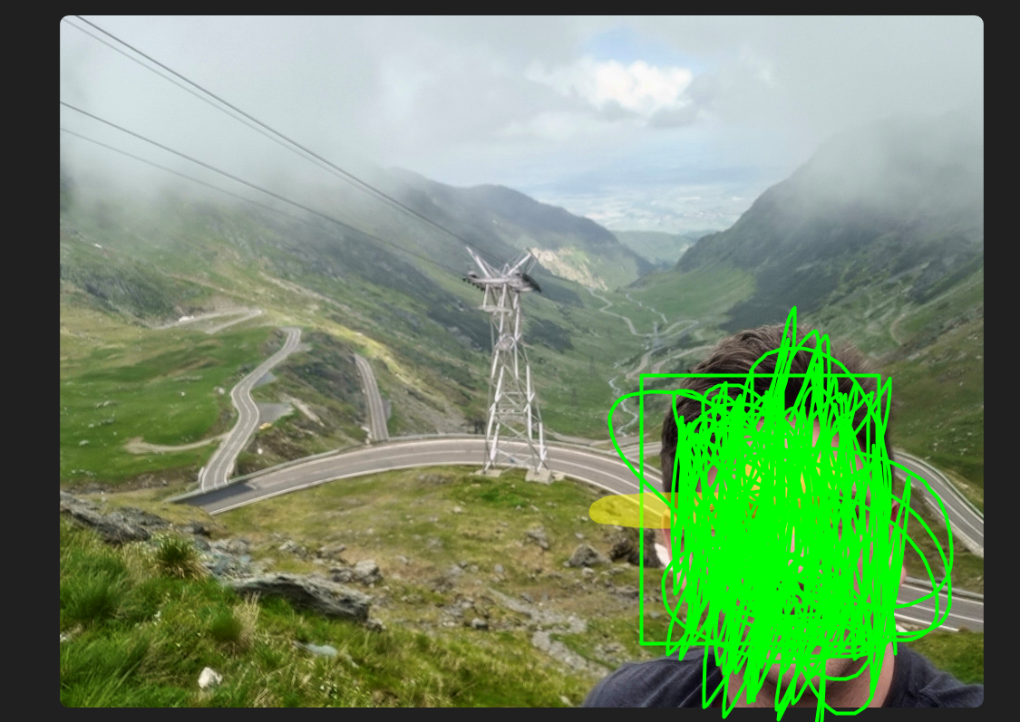

**27May24**

It's amazing and awe-inspiring and righteous to reflect back on what the might of the Lord has done May 5-26 especially mother's day, Josh bday, snacked the coward demon pedophile demons and Lucifer/Jzbel accross their arrogant mouths. Use the music you wrote the sop with to remind yourself how omnipotent and awe inspiring your Father in heaven is <3

All flory to God, be proud of him and yourself a lil bit it's k hehe

**26May24**

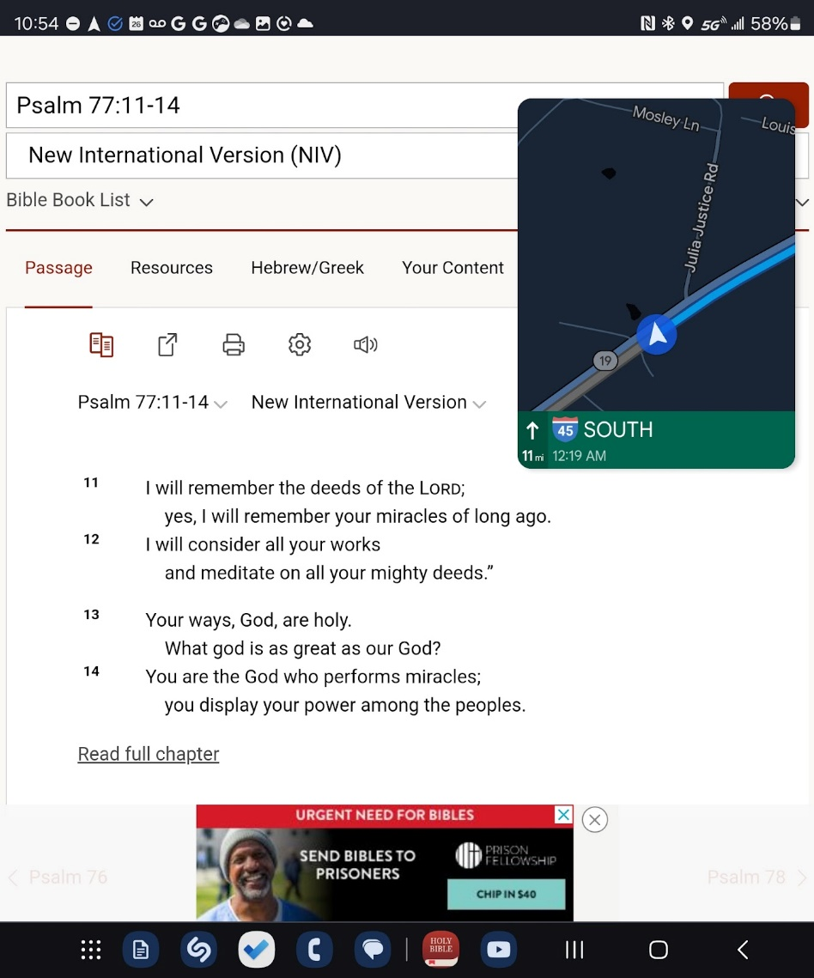

Xxx sermon, remember and build memory stones May 26

He also spoke about using visual objects as reminders of his incredible work. Like a photo of your parents etc. Ty Lord for speaking to me <3

The wonders he worked May 5-26

Remember May 12th

Through you, JC smacked the coward Lucifer and his demons accross the mouth 🤣 😂 🤧 🤪 💀

**25May24**

It's ok to spend money initially to get organized, you have a weird mind, OCD is real, like a high maintenance Ferrari testarosa, your mind works wonders when organized!!! (Like NF hehe)

I mean remember the cancer lab u ran? It was perfect ☺️ This is the way, run your life like a lab/OR!

Remember how much fun you had as a kid organizing And renovating your room? The bag idea u came up with as a Lil kid hehe

Friend or Foe Lord? 🧛‍♂️

Internet Traffic or Audience? 🤔

Ti's difficult to discern Sometimes 🫠

Continously check for tense muscles, this is fear from thinking it is ONLY your.efforts and intellect That makes things happen.

IT IS ALL GOD, HE IS IN TOTAL CONTROL OF EVERY LITTLE THING!!!

**24May25**

Focus on urs3lf now, you've helped others in xxx now focus on ourself and future patients!!!

A good doctor needs to be strong and confident themselves  to help others!!

Stop worrying about those in xxx , you have done your part

Leave it in the rear View mirror do not be Like Lots wife !!!

Help ur patients in xxx now!!!

23 May 24th be yourself work on yourself you're authentic soul and character unless you're identity being Christ don't ever think about what others perceive you as for the most part if you try to build a carriage and other people's minds it'll be like running a virtual machine inside of your computer it'll be difficult to get into your Flow State because your mind is running this virtual machine of this person you're trying to appear as to others work on yourself you're the best you can that way you can be your authentic self and you won't have to run a virtual machine also thinking about what other people think of you is like looking at yourself in the mirror and that leads way to Pride fear and cringe

The devil loves to attack When you pray he knows somehow

**22May24**

do not EVER be DOuble Minded when Fighting for Truth. Make a decision and stick to it calmly. Do not ever permit coward demons to raise your cortisol if its not worth it. Lord guide my temperment, in Jesus name!

Careful not to let anger capture your mind, even if your right, like with Jezebels stop replaying it, the past is the past!!! Look forward.

**21May24**

Dreams, Orthodox jew accepting Christ as his Messiah, him singing in Hebrew about Jesus

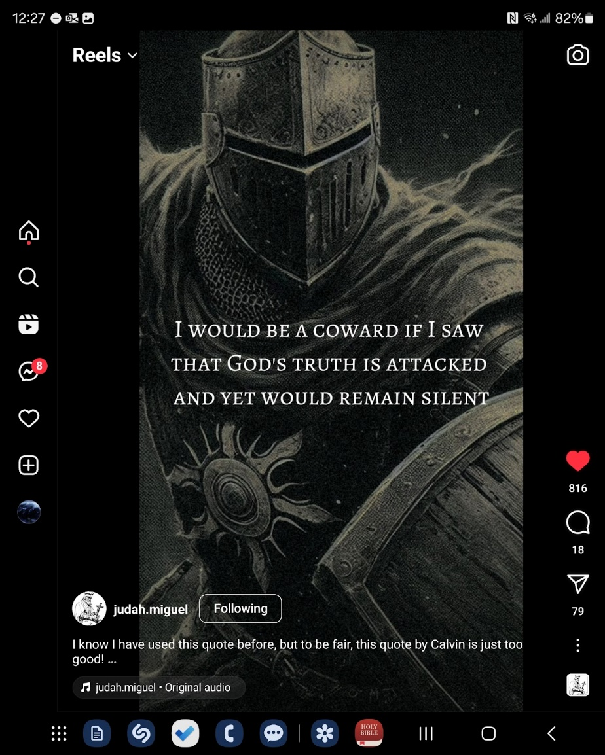

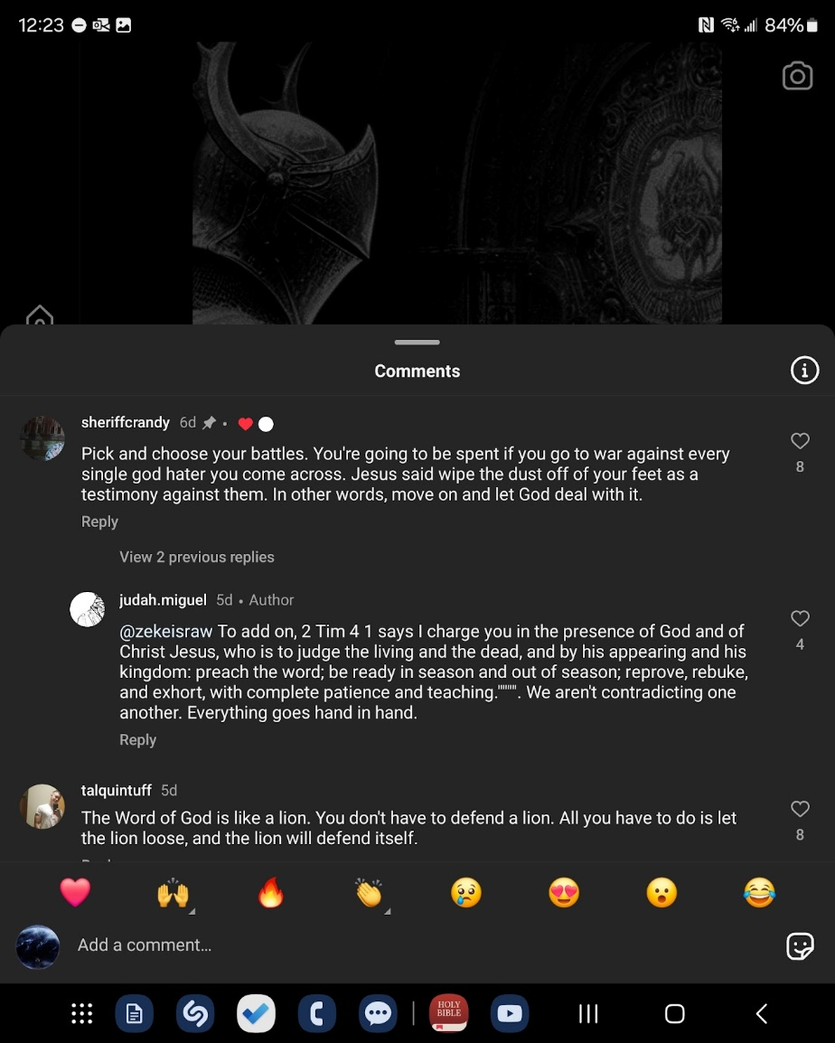

**20May24**

Don't ever practice what you're going to say God will give you the words speak in the moment the most part worrying and practicing we're going to say just brings fear anxiety and doubt of the Lord's guidance

Any fear is straight up doubt of jesus's guidance how can you doubt even for a moment after everything he's done for you and shown you how many more signs do you need bro I love you!

Only fear God!

ALWAYS LOOK FORWARD, LOOKING BACK IN REAR VIEW MIRROR

AND PAST ONLY BRINGS FEAR AND ANXIETY

LIKE LOTS WIFE

LOOK TO THE FUTURE WITH AWE, JOY, AND

THANKFULNESS! 😊☦️

19May24 REMEMBER TO BE RAVENOUS FOR TRAINING AND LEARNING, RISE CUSTODES <3 Do not ever look at church or learning from the Truth as boring/depressing, (trick of the devil) visualize it as you study medicine, building the ultimate 3d memory palace, and learning wonderful things about God’s mind and design, how much more exciting is it to learn about Gods amazing plan/visions/ and prophecies!!! So much better to learn the ways of the custodes!

Be like <3, Say… Who Gives?

Sleep paralysis last night, felt as if suffocating, horrible lol

 God damned coward pedophile demons attack when u sleep, and mind is vulnerable, But God was still stronger as always. Had to wake out of 2 step inception dream plane to cast out the coward…

Stream

Spanish worship <3, eyes are quick to judge, better sometimes to close your eyes and listen and learn about their message and spirit <3, always remember your mental training when swimming a race

Always be humble and learn <3, there is always more to learn, thats what makes sanctification exciting!

Preaching about bible translations, to get the word to EVERYONE for salvation, before the end times.

Greek word for appearance is the following, Talking about Christmas Mourining/ Morning at 30:42, son has always existed, yet he appears as sun goes around earth

Storm at GC house, knocking over chimney, santa clause not coming this year for christmas lol

Roots of fatih deeper than trees! Your house is now built on JESUS! The lord destroyed your old house in 2022-23, the foundation JC was still there, but it was a small portion of the concrete, now you are building EVERYTHING, work, friends, family, workout, diet, EVERYTHING. THANK YOU LORD FOR DESTROYING EVERYTHING, SO THAT I MAY REBUILD EVERYTHING ON THE FOUNDATION/ROCK OF CHRIST

JESUS RETURNING!, WAIT ON THE LIGHT IT IS COMING (JOKE BECAUSE OF HOUSTON APOCALYPTIC STORM HOUSTON ON 16MAY24 HFBC WAS WITHOUT POWER, LIKE 12MAY24, AND LIKE 2ND BREAK maybe look it up?

[Houston storms: Winds howling in Montrose area | 5/16/24](https://youtu.be/IBxZkyEiN9k?si=dZ22ZLoZcNLFH89B)



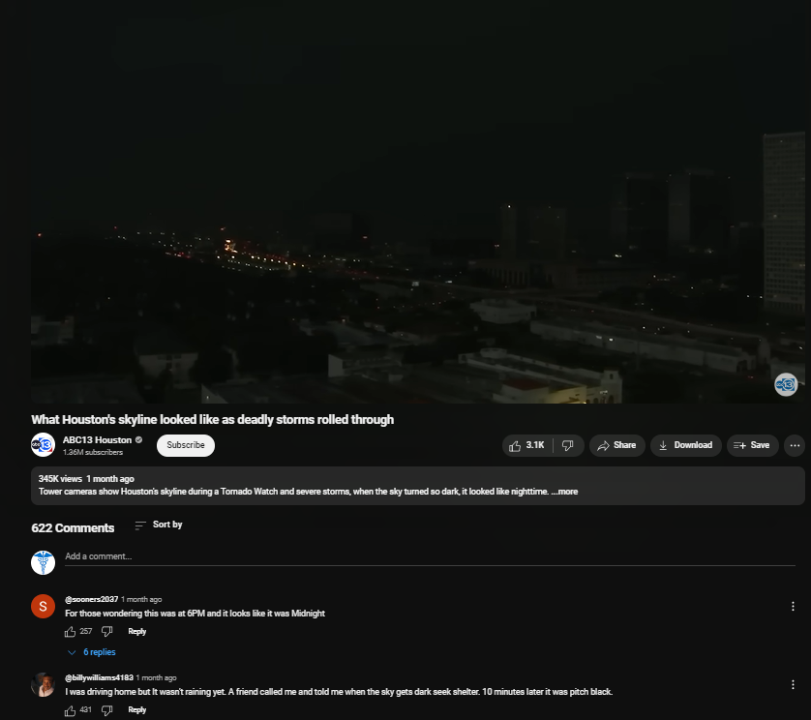

[What Houston's skyline looked like as deadly storms rolled through](https://youtu.be/WIUBtf4B8KQ?si=eXzhPSM6X-kPNUU9)



GOD IS AT WORK IN OUR WAITING! Part of Custodes training! This is what you are becoming praise God, learn ravenously for the Lord, welcome trials, the LORD IS TEACCHING YOU UNSEARCHABLE THINGS WITH THIS.! <3 <3<3

A PEOPLE FOR HIS OWN POSESSION, HE LIVES IN US, WE LIVE IN HIM, EAGER TO DO GOOD WORKS, PROCLAIM THESE THINGS

11For the grace of God has appeared, bringing salvation for all people, 12**training us to renounce ungodliness and worldly passions, and to live self-controlled, upright, and godly lives in the present age,** 13waiting for our blessed hope, the appearing of the glory of our great God and Savior Jesus Christ, 14who gave himself for us to redeem us from all lawlessness and to purify for himself a people for his own possession who are zealous for good works.

**Declare these things; exhort and rebuke with all authority. Let no one disregard you**.

CHURCH MAYBE WITHOUT ELECTRICITY BUT IT IS NEVER WITHOUT ELECTRICITY

He said sunday pentecost is taking place, Gods power through the church, like a 40k emperor titan is NEVER WITHOUT POWER =)

Dont trust in the worlds generator, trust in the POWER of God.

22And I saw no temple in the city, for its temple is the Lord God the Almighty and the Lamb. 23And the city has no need of sun or moon to shine on it, for the glory of God gives it light, and its lamp is the Lamb. 24By its light will the nations walk, and the kings of the earth will bring their glory into it, 25and its gates will never be shut by day—and there will be no night there. 26They will bring into it the glory and the honor of the nations. 27But nothing unclean will ever enter it, nor anyone who does what is detestable or false, but only those who are written in the lambs book of life.

**18May24**

Save your boiling blood ONLY for the UNREPENTANT COWARD PEDOPHILES DEMON MONKEYS

SAY WHO GIVES?

Make a Decision with JC WISDOM and stick with it. DO NOT be double minded, this is likely WORSE, nothing but fears. If it is NOT JC will, it will not happen bud <3

Evil depression/fear/anxiety ALWAYS attack when Seroquel kicks in, likely secondary to your mind slowing down. This was the case for the last 2 manic breaks, waiting up feeling like your sufocating, drenched in sweat, xxx said you were screaming in your sleep… the pattern of evil attacks is clear, don't EVER doubt His imprint and signature since you were lil, he was ALWAYS with you, my friend <3 I love you JC!!! <3. Practice what you preach, DONT EVER equate your feelings with JCs mercy, love, and salvation. NOTHING CAN SNATCH YOU OUT OF HIS HANDS!!! <3

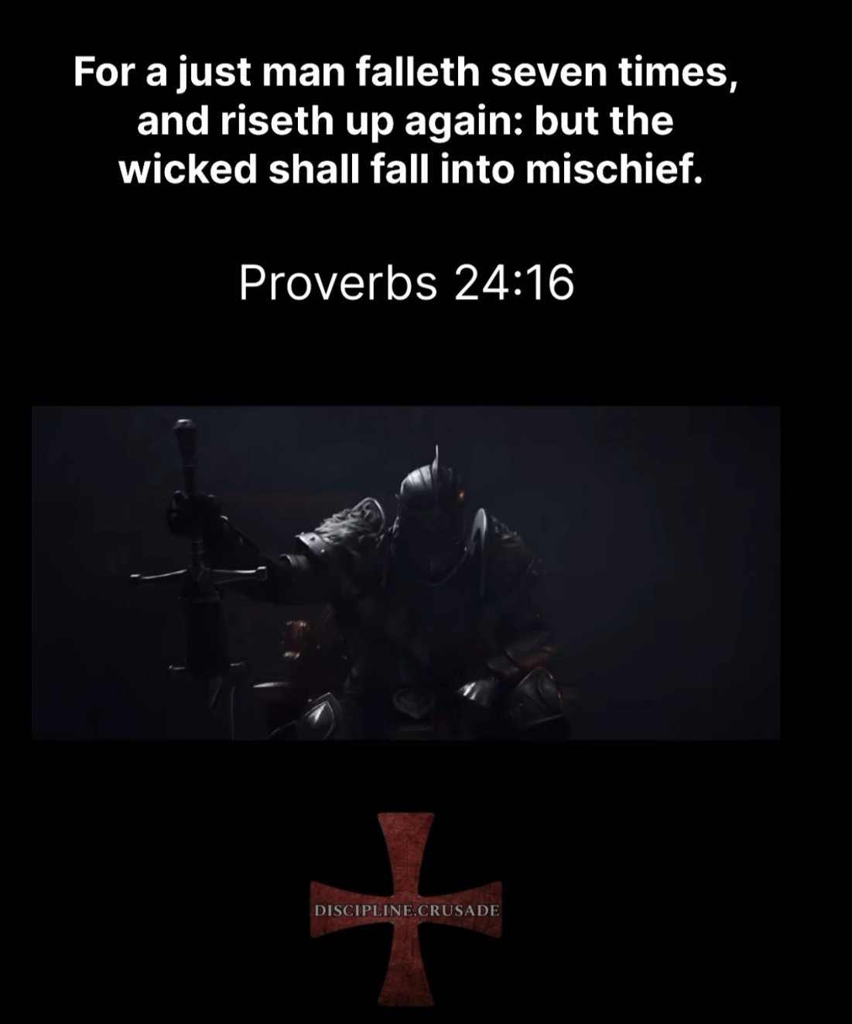

**17May24**

"If our minds are ruled by our desires,  we will die. But if our minds are ruled  by the Spirit, we will have life and peace."

-Romans 8:6

Like you being super anxious about your apartment, etc. Let Gods will be done! Be at peace child, your loving Father has everything under control. You don't have to worry about every little thing, God is always working for your good <3 Remember your kingdom is not here =)

Also you will be wounded, bruised, you may fail that's cool, learn from it and don't dwell on the past! Look always forward, do t dwell on the past, thank God for everything!

Treat everyone with Love! Love all Humans <3

God mocked the Egyptian gods, Elijah with the pillar asked, maybe your God is relieving yourself. Lolol

How amazing it is to do something for the Lord <3 ALL THE PAIN, thank you Lord for teaching me… I am not worthy Good God, thank you for adopting me into your family <3 🥰

Demons will try to give you signs and fear through their demonic network and through people

Angels will do the opposite of demons

Together we will become a pysker Titan for the emperor, until he Returns

OF stream LOLOL use his weapons against Morgoth!!!

If we are to imitate JC, he ate with those society deemed lowly and depraved etc. who needs a physician if not the sick Jesus said…

Do nothing for glory on earth, DO EVERYTHING FOR GLORY IN THE WARP!!! (Spiritual realm.etc)

Imagine yourself in an Abrams X designed and built with Holy armor given by the Lord JC, with unlimited fuel, fighting against horses of zombies (chaos demons)

*Untitled - Notepad

File Edit ormat View

Help

Streisand/LUCIFER DISS Experiment 4117

Let's see who really is in control ;)

This simple innocent question keeps BANNING me

Im either a LIAR or A LUNATIC (por que no los dos

Like BANNED from 4chan /pol (LOL the hypocrite

4C3

om

Reddit,

2

ang

posting

EG

ANYWHERE!E

Do you think God is using the NF song "That's

d1S Lucifer Publicly

and remind him of his impending casting into eternal darkness and pain???

"The Devil, the Proud Spirit

annot enqur E tO D

ike a illshot Diss CO

in the spirit/chaos realm

Lucifer but

You know since Jesus is being Mocked everywhere.. God does a Reverse Uno 1ol and slaps the coward

accross the mouth LOL God uses bad and turns it into Good all the time!

Will anyone atleast make fun of my siliness P1z ne one wants ta talk to me

(I am not, nor have I have ever been suicidal, just putting that out there lol

Like my accounts are permabanned without any votes or inauiring conment= despite

10005 of views I just want some thoughts on the idea plz <3

See if you can comment etc..-

A1so THIS TEXT BOX KEEPS DISAPEARING FOR NO REASON LOL, IM GOING TO SLEEP NOW.

Disapearing window count #11 !l (noobs, may the Lord bless the HUman

and Rebuke the chaos

Disapearing chat repost #2 <https://pastebin.com/xcg3nWCn>

MY CHAT STOPPED WORKING LOL

Lucifen hates this message LOL, Its ok the censorship data is adding to our blinding swarm <3

LOVE ALL HUMANS, RIP and TEAR ONLY into the Chaos Demons without MERCY

Ask yourself how a message to LOVE ALL HUMANS and RIP and TEAR only DEMONS is offensive?

REMEMBER the COWARD LUCIFER (AKA spirit of pride) is the root cause oF ALL RACISM, ANGER, AND RILIGIOUS

BIGOTRY!!!

LET THE COWARDS OF HELL TREMBLE, they WILL BEG AGAIN at the FEET of Christ (AKA God)

The very PLATONIC FORM of depression/fear you DEMONS torture us HUMANS with will be cursed upon you for

ALL ETERNITY in the Void. Their attack frequency and amplitude is increasing drastically accross

the web of the immaterium... Imagine not knowing when you will have the Platonic Form of DESPAIR placed

upon your head. Their time draws nigh... Let the COWARDLY DOGS TREMBLE <3

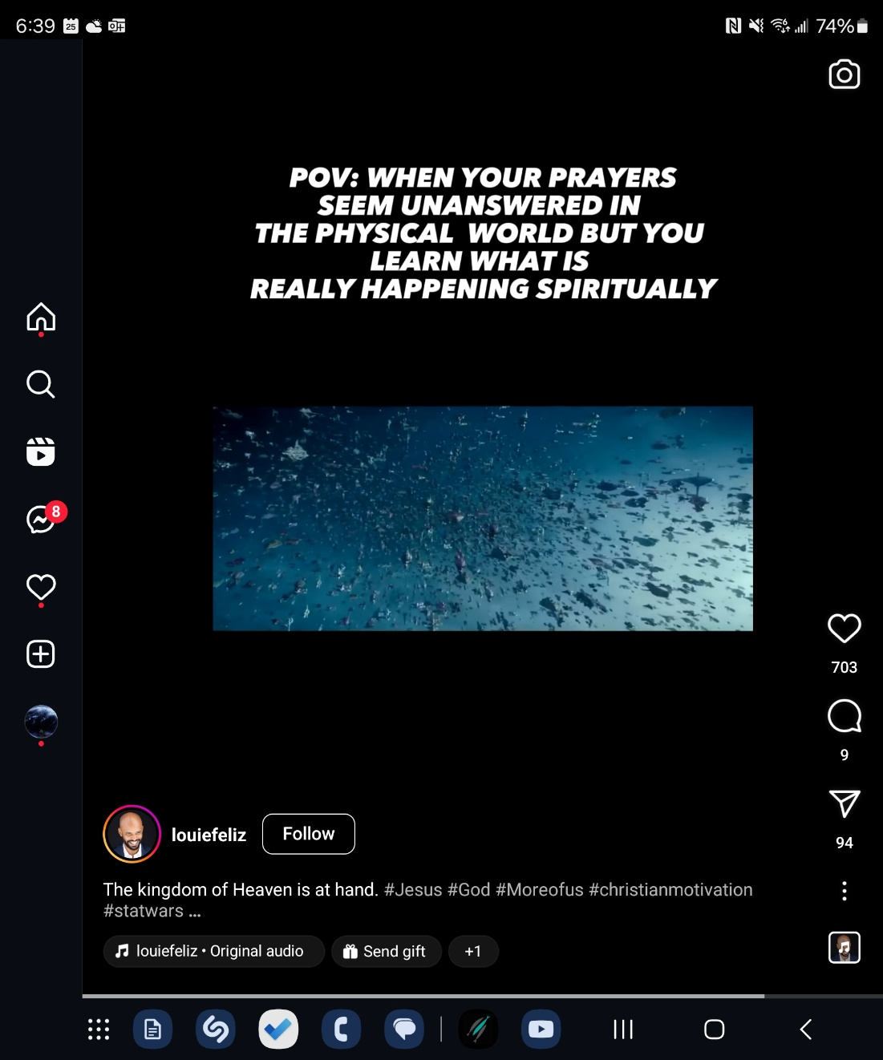

**22May24**

Do corpos put annoying interruptions while on hold to annoy you? Like its music, then lady saying to go to website, then music, repeat over and over and over again. Atleast for me it triggers my rage. Music is interrupted with BS message, you get oyur hopes up thinking you have someone, and then its just a message saying go online. Thats some dark psychology bullshit if ever seen it. Greedy demon cowards! Also WTF lifesaver, all you say is over 10 minutes??? You are always under unusually high call volumes even though its Wednesday at 1545???

Do spirits of fear attack animals too? 🤔

Why does Pride spirit of West (Jezebel) align with Pride Spirit of East (Lucifer)?

The tarnished will be the bass in the Emperors symphony, and the sword of the Emperors Titan

God is light, are fallen angels EMR out of vis spectrum? can mess with Electronics? Static on answering machine? Can cause halcucinations be distorging electrical activity of brain? Seizures are electrical storm of brain. Is possession full control of motor cortex? For me my stomach rages in pain when I get close to evil, EMR activating/triggering autonomic nerves ? Gobbly gook?

Sense of impending doom, is likely from demons who are crazed in fear of their casting into ETERNAL VOID AND FIRE

If xxx is jzbel she would know xxx greatest fear maybe it's losing money? Just as Mom knows and spits out my greatest fear.

You can have this powerful faith in EVERYTHING, God is in control, and when you do his will he also gifts you with things you like =) like a cool apt that's affordable! Or an amazing 4runner hehe <3

What happened to the demons after the pigs comited suicide? Did he have mercy or cast them into early retirement in eternal despair?

God damned cowards, they likely do not know what faith is, how can they trust the father of lies lol? they likely don't understand it. They never needed it…

The demons are afraid now, they should be, my Lord JC is omnipotent!!!

Little faith like a seed can move mountains into the sea!!!

Without pFc they are POWERLESS!!!

**13May24**



Thunder and lightning, playing halo lol, Winnie was terrified (was she abused before? 😭 During a storm?) idk, but she has experienced intense fear previously and it's linked to storms. (PTSD) She was frantically looking around like she is seeing demons storm around her, even when I was trying to console her, brought her in bed, holding her, she was still shaking. The power went out, turning off Halo, and that's when I tried to console her in bed. It's like she was staring at the demons of fear and focusing on them, instead of on me holding her and looking straight at her. I could not get her to look at me even when trying to move her head to face mine. The thunder and lightning went away (rather suddenly) after I talked to Emma, then Winnie relaxed and fell asleep <3 Is this what happens when we focus on fear instead of Jesus? This fear demons inflict on us, this dread, this hopelessness, this focus on the feeling of fear lasting for eternity without hope, this is the ultimate form of fear, fear entered the universe likely when the angels turned, fear of the Lords eternal damnation darkness, depression and anxiety. This is why they begged JC for mercy to not cast them into this fearful darkness before their time. This is the fear and depression they share with us… Thank the Lord We are saved by grace and not by works, works come after naturally because we want to glorify the Lord and be proud of his might and mercy 💪💪💪

Be a dragon for the Lord hehe! After all he did design them!!!

Be a sorcerer ONLY for Jesus Christ. The Bible is your “spell book” (emphasis on metaphorical speaking) Learn the scripture well, each verse contains a beautiful spell to wield only against demons. Use each spell often and you will burn the verse into your very soul.

Always pray the other Adeptus in the bloody battle!

Fear always blinds the amazing guidance and signs He gives us. If fear is not of God, it is from evil

District, disobey,etc

Remember, be slooooooow to anger, yes you are proficient in it, do not flash into it. You try reflect other parts of the emperors spectrum for the most part, ur gonna get htn lol

Raw rage can haunt you too bruh, breath a lil =) love your God!

Be careful how you interpret things, you may misinterpret from a spirit of fear, if this fear is not from God, throw it in the ground! I'm an adult!!!

Evil can use physical attacks to distract you, e.g your stomach ulcers, cold sweats @ night.

If the God damned cowards cannot attack your spirit they will attack your body!!!

The God damned cowards are getting boring, their foolish plan is too predictable lolol

Keep attacking, it just adds to the data fools!

Mercy he gives us is abounding (beautiful conjunction <3)

Nothing we do, earns us his majestic mercy <3

Willingly gave us Christ, as we were yet horrid sinners

Our position never changes!

Grace, un deserved favor given by a superior without the expectation of anything in Return !!! When you fall, there is the temptation to try and work back into his rest! Other religions are devil driven hence they try And WORK their way to God. Christ changed this completely. God only permits attacks that he knows you can handle! Learn from every battle.😉 We are all afraid of failing! Like God would start abusing us with a mistep! When you try and worry about what others think about you it's exhausting! God does not he's pleased with us because he sees his son we are adopted! =)

What does workmanship mean? And what purpose? Building up the amazing church of God, building blocks!

Wet in God's work for us to mold us more!!!

XXX is also your family!!! <3



**12May24**

Mothers Day

Xxx Sermon

A wise older man needs to be fun but not necessarily silly. Be worthy of respect as well.

A wise man invites wisdom!!! And loves instruction <3 this is how u, build up the power armor of the Lord! 💪

God will bless you with amazing signs by his grace before every battle.

Construct additional pylons/memory stones and do not let the fearful swarm darken these pylons, trust in the amazing pattern he has shown you! Stop doubting put it to DEATH IN JESUS NAME FEAR, PRIDE, AND CRINGE!!! NOW

The indisputable signs from God at xxx one week after stream on 05May24!

We must construct additional pylons! Mothers day

GC smile

Disney princess theme (Mulan!)

Conjunction of spheres

EMR Jehovah

Spirits of the air focus by revival teacher then apacoplytic storm 16May24 preventing xxx from in person service and you seeing your LBS again

Calling mom dark sign during revival LBS =/ falsely saying you physically abused her??? Like xxx said to xxx… Jezebel is trembling in fear lol!!!

Jezebel is such a a cringy whore lol

Walking with God devotional

Embrace your age and stage

**God i heard you! <3**

Let us be the men you created us to be!

Phys, emotionally, financially, sexually

God always has an imptint in your life, as always he turns the bad into good! It is good to see the bad and see just how his amazing work and love! All of our bad stories, turns to sing a wonderful song of redemption to his ears =)

Your pain, sin, etc failures, will show what the clay was before and after his molding (although the molding is difficult ) DONT HID OUR STRUGGLES so that, shows how merciful God is!

Pharisees always wanted to seem better than they were!!! Burn this into your soul!

It's ok to have your insecurities to show his grace and power on our lives!!

Not a result of your works bruh! Be obedient to what God has called us

Handiwork God is not a crappy craftsman!!!

Pray for other people protection too, other people are probably being ruthlessly attacked, pray for them as well it's not all about you bruh!

Christ is King of the 40k (corrupted) universe after all

Lucifer is an abusive father, father of lives

When we worry about the future, we think Of God as this luciferian father, we have almost have a picture of Lucifer when imagining this

God the Father is a the perfect form of a loving Father, he will discipline when needed, but you don't walk on Egg shells around a loving father. Even when you fall, he gently corrects you.

Working for the Lord is not easy.

xxx is the pharisee in carnate.

40k lifted to Jesus

Last thing you said to xxx was that her mom was wormwood Jezebel

I was getting angry at her not the demon of Jezebel

Be like baby driver 🤣 with music, pride fear cringe lol

It's ok to rest man! Spiritual warfare is brutal, you are flesh, remember, the diss track is out in the immaterium now. Let other do the work. God will guide you!

If the HS is using you he is using other =) we are all the doom slayers!

Learn to rest man, His will, not your own!

Dude, most people would have gone mad doing this, You are still sane, God made you strong! Rest with Him! Relax man, be at peace stop thinking about things.

Tolkien LOTR is a (comparatively) cheap reflection of what Heaven

Spiritual battle is exhausting! Remember ur fight with Mom and you fainted. Rest! Give it mind a break, u are flesh after all <3 God loves you, do you think he would be mad at you for trying to do something for His glory??? He is not mad at you <3 it's ok to be weak, you are weak, His strength will be made evident in your weakness <3 thank you Lord for teaching me to rest!

Jesus rested in the wilderness silly! It's an example for people to rest!

We are a corrupted wave mind body spirit oscillating out of phase with Jesus.

The very word of God what he speaks, is the true wave we should oscilate to. The more we study and listen and apply it, the more correct our frequency is.

The closer to God we get the more we negatively interfere with other beings

I'm summary trust God lol !!!



**09May24**

Spiritual warfare day after crashing

Stop thinking what ur gonna say to people, especially if u feel fear, God will give you the words to say, don't say anything in fear, you are God's child whom he loves!

DONT EVER EVER EVER THINK YOURSELF BETTER THAN PEOPLE STRUGGLING WITH THEIR OWN DEMONS. YOU KNOW HOW HORRID IT IS. HELP SLAY THEIR DEMONS WITH THEM!

Depression is similar to fear, squash one depressive idea and another comes around, always have hope!!!

Always count others more valuable than yourself

Don't ever be fooled only God the Father knows when Christ Returns!

🤷‍♂️🤷‍♂️🤷‍♂️ Kill the pride, be humble, just drive like baby driver, with child like faith, in awe and wonder!

Be a demon slayer for your family, for the pain and suffering they are inflicting on your mother father sister niece, nephew.

For causing xxx so much stress crying and with acne

God is doing amazing things, wonderous things sometimes it's too much to contemplate. This can also lead to pride and fear. Don't look in the past, look at the wonderful future! In awe and amazement! Amen

Make your ancestors and angels proud ! =)

Don't make a charicture of yourself in your head. You are who you are in Christ. Be at peace, it brings peace to others!

When you are thinking about fear and oppressed by it many times others are as well. Capture and rip and tear, learning it's anatomy and physiology and weak points to the Crucible of Christ!

What has been out to death leave in the grave, stop dissecting the rotting flesh to learn and second guess yourself!

How about you trust God as much as you did alcohol years ago? He's sooo much better bro! KTP KTF

Mania/Psychosis is primarily a spirit, secondarily meds!

We will continuously mock Morgoth in front of his cowardly armies. As the cries and the time of their begging draws near descension will flow like corrupted blood through their cowardly dog like ranks

If our fear of God is holy Spirit driven, and earthly fear driven by demons, what is the fear spirit of the demons? Why must be very wise lmao (Bible joke lol)

God also gave you free will to exercise your character, your brethren have their own character, different parts of the Body ITS ALL IMPORTANT!!!!

Don't make provisions for the demons, like if someone is fearful don't tell them your psych history. Lol love others and be protector of your fellow men

Advantages and disadvantages to this fleshbag suit, too much chaos attack, just lake your Seroquel and demon won't have too much power?

Am I going Insane? (No) This is advanced spiritual warfare, this is why you were trained in it since a young age, no more, have Hope, take the reigns! Learn to be a Grey Knight for Christ!!! Keep fighting and taking notes of these trials God is putting you through. No Fear, ever,

Unbeknownst to NF, since he is fleshbag like myself…

If you wanna attack God is with you, if you wanna rest God is with you, be always at peace with him, kill the pride, pray for others, rage at their suffering.

y'all think That's a Joke is the Holy Fire publicly mocking Lucifer?

Whatever the devil can do, God can do better (reverse Uno Morgoth, sanctify the perverse)

Be open to learning you will NEVER BE PERFECT! Don't imagine conversations, God will give you the words to speak, have Faith. Never fear (365 times in the Bible)

God lets you make your own ideas and actions. Like stop OCD ing over your next step, give everything to Him

God will be with you even in your mistakes silly

NF sub reddit lol

You are learning an incredible amount about there tactics, I think it's still good 😊, not everything you imagine will come true 🤷, and that's ok, u will make mistakes, get to work!



5/7/24

Woke up in sweat after 2 hours of sleep, stomach hurts, heart hurts Weird vivid nightmare, I realiEd upstairs next to blinds Dad was a shape shifter. Sitting next to Mom rubbing her feet or something, I kept trying to cast demon in dad out, as I sat him Down and looked him in the eye, he kept calling me crazy, until he just started giving me a nauseating smile, I then realized he was Lucifer himself, pride, I could not cast him out, he just smiled at me. Christ will deal with Morgoth himself! God will help you fight pride amen!

Fight fear, pride, cringe!

(You always said he was the most prideful man, but at times cowardly. Anyways I was sitting next to Mom

,

Same as music looking at a cross can be corrupted if you pray to the cross as an object, if you use it as a symbol, with your spirit towards God it is fine. Corrupted songs can be sanctified if you lift them to Jesus Christ Lord of Lords.

They mock our emperor on this planet, let us mock their emperor in the warp and on his plane back =D

We will be as darkness on this plane, blinding fury of fire in the warp!

When they take your meds, you will go manic for Jesus lol

Just go with the flow, stop scanning for signs, be at rest and walk with Him!

with discipline!

**19Apr24**

(Day of psychiatrist visit) There was so much evil there, my right arm turned purple, while you were gleefully sharing how you committed adultery, sharing how you would tell my father the intimate details and positions. Evil was done against you through dads promiscuity, but he repented and is now forgiven by Christs blood. You then took the evil against you, and multiplied it for revenger. You repayed evil with evil that was orders of magnitude worse than Dad's. xxx and xxx remember vividly the men you brought home. Ripping into their souls, traumatizing them now to this day. My older brother xxx ONLY STUTTERS when he recounts this evil. This breaks my heart to think how deeply you wounded xxx. Xxx remembers the abortions you carried out with coat hangers…. That could have been me. Am I even my father's child? 😭

The way you speak and recount your sins leads me to the conclusion that you indeed HAVE NOT REPENTED. Like the coward Lucifer does, you remind people of their sins and mistakes and use this to channel spirits of pride, anger, and scoffing towards everyone around you. You and xxx are so oppressed by JEZEBEL, that it is difficult to determine if you are posessed or heavily oppressed (I'm hoping for the latter)

Mother, I know you know the Lord. I know it, but you have fallen in love with pride, anger, scoffing, (Jezebel) you enjoy the rush Jezebel gives you. Repent of your sins and cast out this Demon destroying my parents. Please, I do not judge you, you are the most amazing mother I could have asked for. You taught me incredible things about the Lord, life, and how to be a KGB agent for the Lord ;). I love you, always, and forever. Just like you (in your boundless love for me) cannot sit around while I indulge in alcohol (strong spirits) and pride. I cannot sit around and watch Jezebel destroy you, my father, and our family. Until you truly repent of your aforementioned sins, you will not see my face. I am your Theodore, I will always be a mamas boi, please in the name of JESUS CHRIST repent of this evil.

Note, do not visit me in xxx until I see true repentance and respect for your husband's Christ like authority. Mom our enemy is not each other, but rather the demons infusing us with rage and anger towards each other. Let us both win with Christ <3